Hardware Test (Verification) Report

for SafeSpace2.0

Content Page

1 Scope 5

2 Used Tools 6

3 Safety Controller 10

3.1 Clock and MCU(: HF101) 10

3.1.1 Test purpose 10

3.1.2 Tools 10

3.1.3 Procedures 10

3.1.4 Test result 10

3.1.4.1 Test condition 10

3.1.4.2 Measure value 11

3.1.4.3 Test result 14

3.2 Watchdog function(: HF102) 15

3.2.1 Test purpose 15

3.2.2 Tools 15

3.2.3 Procedures 15

3.2.4 Test result 15

3.2.4.1 Test condition 15

3.2.4.2 Measure value 16

3.2.4.3 Test result 17

3.2.4.4 Other confirmation test waveform 18

3.3 Power supply function(: HF103) 19

3.3.1 Test purpose 19

3.3.2 Tools 19

3.3.3 Procedures 19

3.3.4 Test result 19

3.3.4.1 Test condition 19

3.3.4.2 Measure value 20

3.3.4.3 Test result 20

3.3.4.4 Other confirmation test waveform 21

3.4 Encoder function(: HF104) 24

3.4.1 Test purpose 24

3.4.2 Tools 24

3.4.3 Procedures 24

3.4.4 Test result 24

3.4.4.1 Test condition 24

3.4.4.2 Measure value 25

3.4.4.3 Test result 27

3.5 Current sensor function(: HF105) 28

3.5.1 Test purpose 28

3.5.2 Tools 28

3.5.3 Procedures 28

3.5.4 Test result 28

3.5.4.1 Test condition 28

3.5.4.2 Measure value 30

3.5.4.3 Test result 33

3.6 Safety input function(: HF106) 35

3.6.1 Test purpose 35

3.6.2 Tools 35

3.6.3 Procedures 35

3.6.4 Test result 35

3.6.4.1 Test condition 35

3.6.4.2 Measure value 38

3.6.4.3 Test result 52

3.7 Safety output function(: HF107) 55

3.7.1 Test purpose 55

3.7.2 Tools 55

3.7.3 Procedures 55

3.7.4 Test result 55

3.7.4.1 Test condition 55

3.7.4.2 Measure value 57

3.7.4.3 Test result 61

3.8 STO function(: HF108) 63

3.8.1 Test purpose 63

3.8.2 Tools 63

3.8.3 Procedures 63

3.8.4 Test result 63

3.8.4.1 Test condition 63

3.8.4.2 Measure value 64

3.8.4.3 Test result 66

3.9 Temperature function(: HF109) 67

3.9.1 Test purpose 67

3.9.2 Tools 67

3.9.3 Procedures 67

3.9.4 Test result 67

3.9.4.1 Test condition 67

3.9.4.2 Measure value 68

3.9.4.3 Test result 68

3.10 EMIF function(: HF110) 69

3.10.1 Test purpose 69

3.10.2 Tools 69

3.10.3 Procedures 69

3.10.4 Test result 69

3.10.4.1 Test condition 69

3.10.4.2 Measure value 70

3.10.4.3 Test result 71

3.11 Brake control function(:HF111) 72

3.11.1 Test purpose 72

3.11.2 Tools 72

3.11.3 Procedures 72

3.11.4 Test result 72

3.11.4.1 Test condition 72

3.11.4.2 Measure value 73

3.11.4.3 Test result 75

3.11.4.4 Other confirmation test waveform 76

3.12 EtherCAT function(:HF112) <- todo 77

3.12.1 Test purpose 77

3.12.2 Tools 77

3.12.3 Procedures 77

3.12.4 Test result 77

3.12.4.1 Test condition 77

3.12.4.2 Measure value 78

3.12.4.3 Test result 79

3.13 AMP board interface function(:HF113) 80

3.13.1 Test purpose 80

3.13.2 Tools 80

3.13.3 Procedures 80

3.13.4 Test result 80

3.13.4.1 Test condition 80

3.13.4.2 Measure value 81

3.13.4.3 Test result 86

3.13.4.4 Other confirmation test waveform 87

3.14 Power control board interface function(: HF114) 88

3.14.1 Test purpose 88

3.14.2 Tools 88

3.14.3 Procedures 88

3.14.4 Test result 88

3.14.4.1 Test condition 88

3.14.4.2 Measure value 89

3.14.4.3 Test result 90

3.15 Safety communication board interface function(: HF115) <- todo 92

3.15.1 Test purpose 92

3.15.2 Tools 92

3.15.3 Procedures 92

3.15.4 Test result 92

3.15.4.1 Test condition 92

3.15.4.2 Measure value 92

3.15.4.3 Test result 92

4 Power Control Board 93

5 AMP Board 93

6 Safety Communication Board 93

7 Revision History 94

# Scope

This is the test report to verify the hardware design specification of safety control module for the robot applications.

# Used Tools

* + - Multimeter

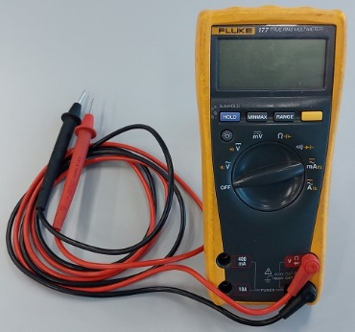 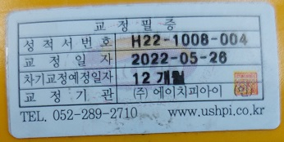

* + - Power Supply or SMPS

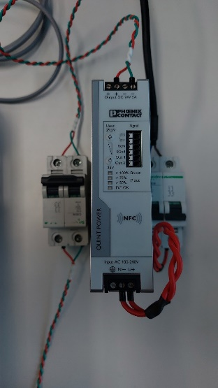 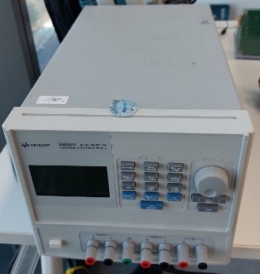 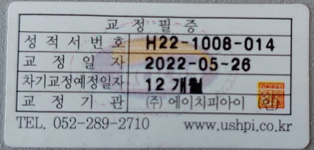

* + - Oscilloscope

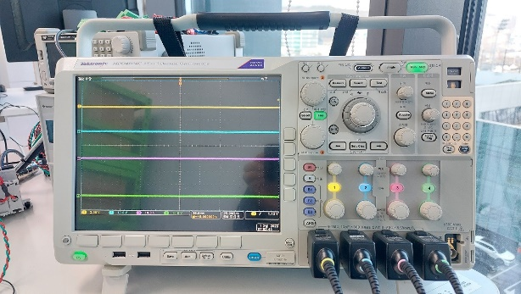 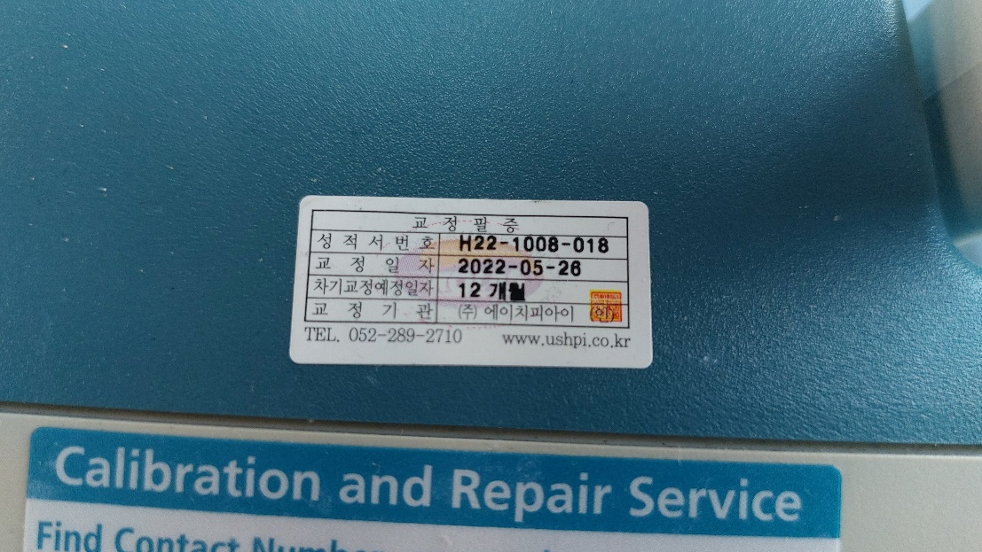

* + - Temperature Meter

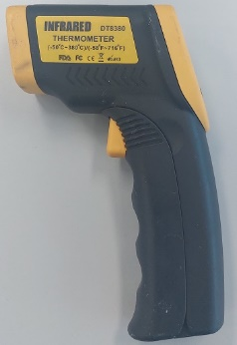

* + - JTAG Debugger tools for MCU1, MCU2(Texas Instruments)

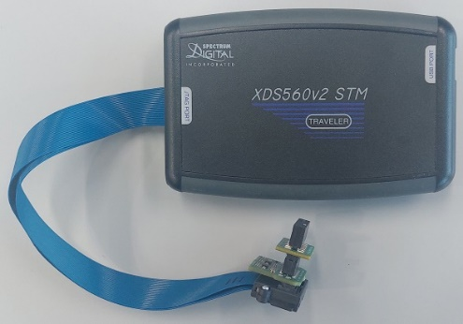

* + - Code Composer Studio(Texas Instruments)

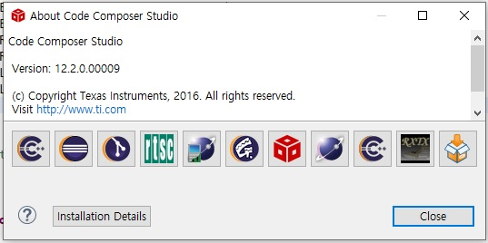

* + - JTAG Debugger tools for ZYNQ(FPGA)(xilinx)

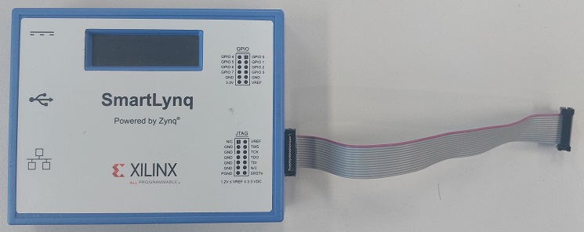

* + - Vivado(xilinx)

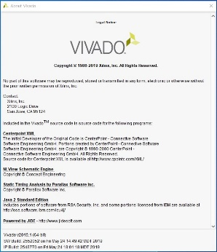

* + - PC(windows 10 or above version)

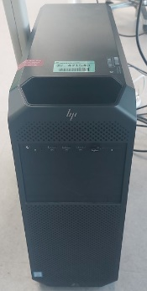

* + - Test zig Board(ZIG_BD642A)

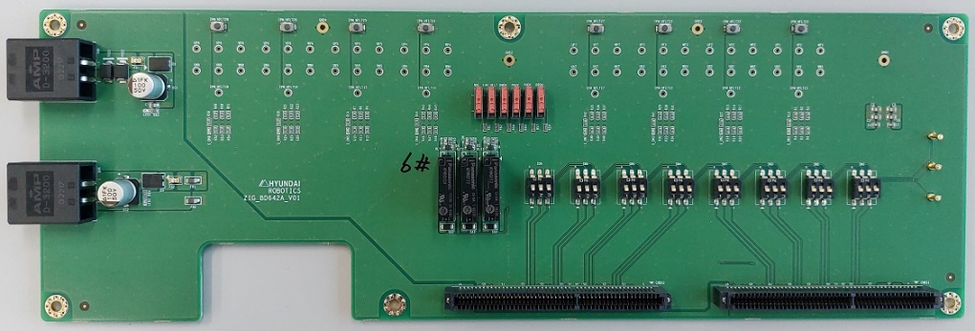

* + - Function Generator

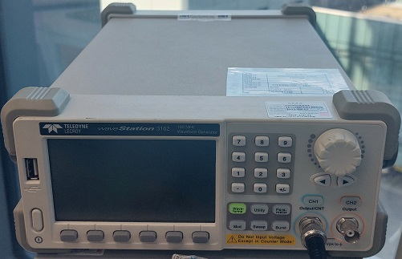 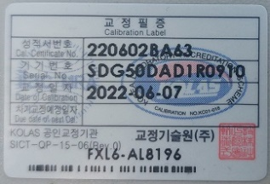

* + - RS232toUSB Converter

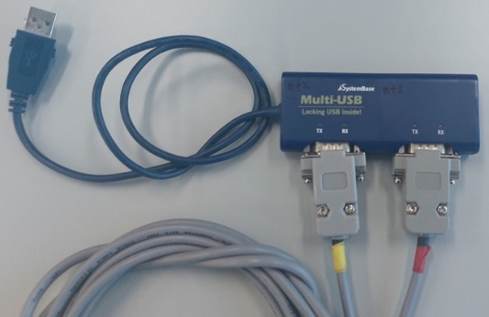

* + - Monitoring and Control Interface

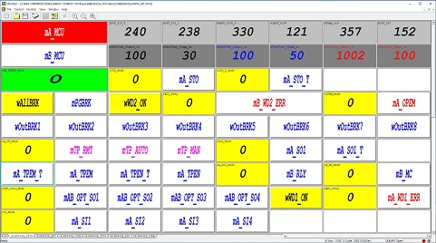

* + - Ethernet compliance software



* + - Compliance test board

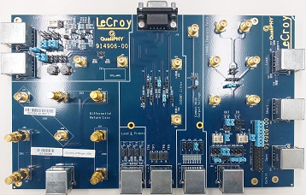

# Safety Controller

## Clock and MCU(: HF101)

### Test purpose

Check the stability of oscillators for reliable system. It is also intended to refer to firmware coding for applications software.

### Tools

For details on the tools used for this test, refer to Chapter 2. Used Tools.

* Oscilloscope
* Power Supply or SMPS

### Procedures

Proceed with the test according to the procedure below.

* Supply DC 24[V]±10% to safety controller with power supply or SMPS.
* Measure and record voltage, duty in each channel’s oscillator.
* Check the duty rate of each oscillator.
* Measure the frequency of each oscillator.
* Measure and record waveform, duty in each digital isolation IC input/output port.
* Check the delay time of each digital isolation IC input/output port.

### Test result

#### Test condition

The test condition for the test is shown in the table below.

* + Oscillator

|  |  |  |  |  |
| --- | --- | --- | --- | --- |
| **Ch.** | **Schematics** | **Schematics**  **Page** | **Measure**  **Point** | **Temperature around**  **measuring point** |
| Ch.1 |  | 5 page | R81 / 1pin | 39.7[℃] |
| Ch.2 |  | 5 page | R95 / 1pin | 35.4[℃] |

* + Digital Isolation

|  |  |  |  |  |
| --- | --- | --- | --- | --- |
| **Ch.** | **Schematics** | **Schematics**  **Page** | **Measure**  **Point** | **Temperature around**  **measuring point** |
| Ch.1 |  | 6 page | U15 / 10 pin  U15 / 14 pin | 39.7[℃] |
| Ch.2 | U15 / 7 pin  U15 / 3 pin |
| Ch.1 | - Omitted due to space.  - Similar to the picture above, only the part number  is different. | 6 page | U16 / 10 pin  U16 / 13 pin | 35.4[℃] |
| Ch.2 | U16 / 7 pin  U16 / 4 pin |
| Ch.1 | 6 page | U64 / 10 pin  U64 / 15 pin | 35.4[℃] |
| Ch.2 | U64 / 7 pin  U64 / 2 pin |

#### Measure value

* + Oscillator

|  |  |
| --- | --- |
| Oscillator(Ch.1) | Oscillator(Ch.2) |

* Duty Cycle: 50.0%
* Period: 40.0[ns] (almost 25.0MHz)
* Rise/Fall Time: 2.0[ns] (20% to 80%, 80% to 20%)
  + Digital Isolation

|  |  |
| --- | --- |
| The specification of digital isolation is max. 100[MBPS]. The delay time of the rising/falling edge is about 10[ns], so it is suitable for the specification. | Rising Edge Waveform  Delay time: about 10[ns] |
| Falling Edge Waveform  Delay time: about 10[ns] |

|  |  |
| --- | --- |
|  |  |
|  |

|  |  |
| --- | --- |
|  |  |
|  |

|  |  |
| --- | --- |
|  |  |
|  |

#### Test result

* + Oscillator

|  |  |  |  |  |  |  |  |  |  |  |
| --- | --- | --- | --- | --- | --- | --- | --- | --- | --- | --- |
| **Channel** | **Component** | **Notation** | **Contents** | **Unit** | **Normal range** | | | **Measured**  **Value** | **Pass/Fail** | **Comments** |
| **Min.** | **Typ.** | **Max.** |
| Ch.1 | OSC1 |  | Voltage | V | 2.97 | 3.30 | 3.67 | 3.25 | Pass |  |
| Frequency | MHz | 22.5 | 25.0 | 27.5 | 25.0 | Pass |  |
| Duty | % | 45.0 | 50.0 | 55.0 | 50.0 | Pass |  |
| Ch.2 | OSC2 |  | Voltage | V | 2.97 | 3.30 | 3.67 | 3.27 | Pass |  |
| Frequency | MHz | 22.5 | 25.0 | 27.5 | 25.0 | Pass |  |
| Duty | % | 45.0 | 50.0 | 55.0 | 50.0 | Pass |  |

* + Digital isolation

|  |  |  |  |  |  |  |  |  |  |  |
| --- | --- | --- | --- | --- | --- | --- | --- | --- | --- | --- |
| **Channel** | **Component** | **Notation** | **Contents** | **Unit** | **Normal range** | | | **Measured**  **Value** | **Pass/Fail** | **Comments** |
| **Min.** | **Typ.** | **Max.** |
| Ch.1 | U15,  U16,  U64 |  | Voltage | V | 2.97 | 3.30 | 3.67 | Refer to  Chapter  3.1.4.2.  Attached  Waveform | Pass |  |
| Data Rate | Mbps | - | - | 100.0 | Pass |  |
| Propagation  delay time | ns | 6.0 | 11.0 | 16.0 | Pass |  |
| Ch.2 |  | Voltage | V | 2.97 | 3.30 | 3.67 | Pass |  |
| Data Rate | Mbps | - | - | 100.0 | Pass |  |
| Propagation  delay time | ns | 6.0 | 11.0 | 16.0 | Pass |  |

## Watchdog function(: HF102)

### Test purpose

Check the stability of watchdog functions for reliable system. It is also intended to refer to firmware coding for applications software.

### Tools

For details on the tools used for this test, refer to Chapter 2. Used Tools.

* Oscilloscope
* Power Supply or SMPS
  + - JTAG Debugger
    - Code Composer Studio
    - RS232toUSB
    - PC
    - Monitoring and Control Interface

### Procedures

Proceed with the test according to the procedure below.

* + - Supply DC 24[V]±10% to safety controller with power supply or SMPS.
    - Download the program for the test using the JTAG Debugger & Code Composer Studio.
    - Set the period of the watchdog1 clock and enable the corresponding function by using RS232toUSB Converter & Monitoring and Control Interface.
    - Measure and record the watchdog1 input and output waveforms, duty in each channel’s oscillator.
    - ~~Set the period of the watchdog2 clock and enable the corresponding function by using RS232toUSB Converter & Monitoring and Control Interface.~~
    - ~~Measure and record the watchdog2 input and output waveforms, duty in each channel’s oscillator.~~

### Test result

#### Test condition

The test condition for the test is shown in the table below.

|  |  |  |  |  |  |
| --- | --- | --- | --- | --- | --- |
| **Ch.** | **Schematics** | **Page** | **Notation** | **Measure**  **Point** | **Temperature around**  **measuring point** |
| Ch.1 |  | 3 page | A_WD_C1 | R48 / 2pin | 30.7[℃] |
| 3 page | A_nWDO_C1 | R50 / 2pin | 30.9[℃] |
|  | ~~6 page~~ | ~~A_WD_C2~~ | ~~R106 / 2pin~~ | ~~31.8[℃]~~ |
| ~~6 page~~ | ~~A_nWDO_C2~~ | ~~R107 / 2pin~~ | ~~31.7[℃]~~ |
| Ch.2 |  | 3 page | B_WD_C1 | R61 / 2pin | 30.7[℃] |
| 3 page | B_nWDO_C1 | R63 / 2pin | 30.9[℃] |
|  | ~~6 page~~ | ~~B_WD_C2~~ | ~~R109 / 2pin~~ | ~~28.9[℃]~~ |
| ~~6 page~~ | ~~B_nWDO_C2~~ | ~~R108 / 2pin~~ | ~~29.1[℃]~~ |

#### Measure value

* + WD1 of MCU1

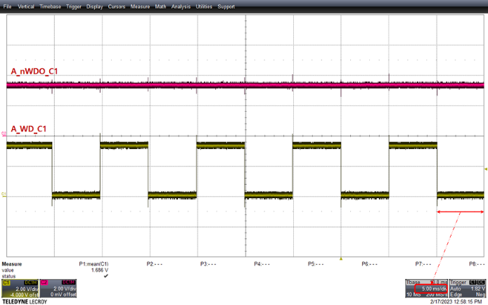 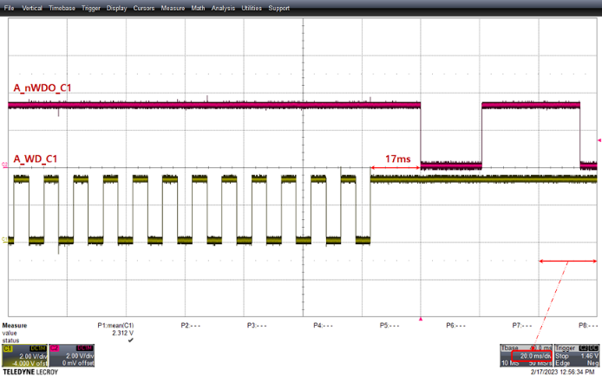

Watchdog Input Output waveform

* + - Watchdog Period: about 10.05 [ms]
    - Watchdog Pulse Width: 5.02[ms]
    - Delay Watchdog Output: about 17[ms]
  + ~~WD2 of MCU1~~

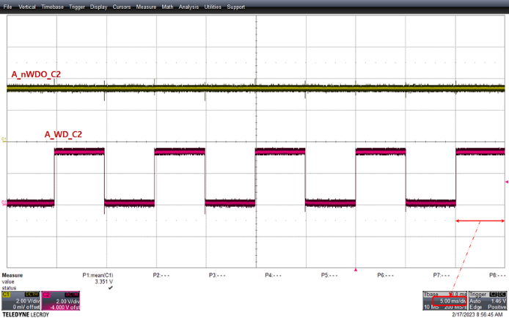 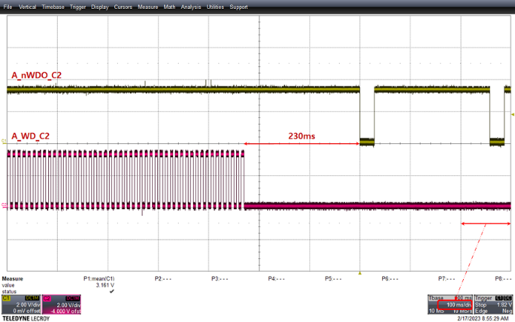

~~Watchdog Input Output waveform~~

* + - ~~Watchdog Period: about 10.07 [ms]~~
    - ~~Watchdog Pulse Width: 5.04[ms]~~
    - ~~Delay Watchdog Output: about 230[ms]~~
  + WD1 of MCU2

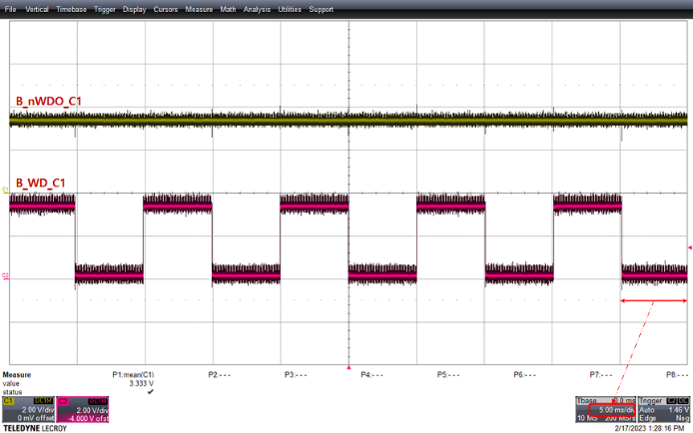 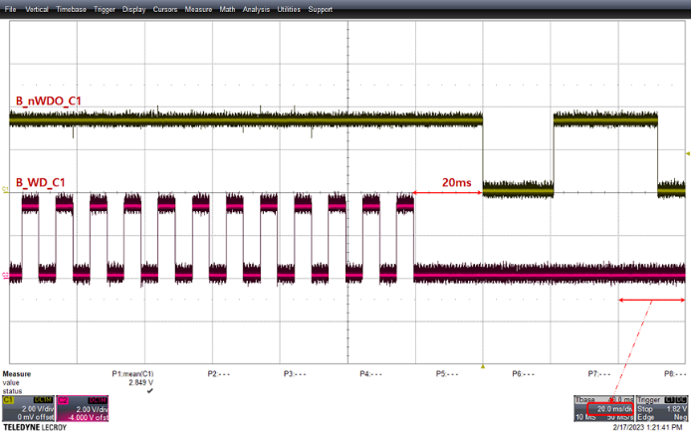

Watchdog Input Output waveform

* + - Watchdog Period: about 10.07 [ms]
    - Watchdog Pulse Width: 5.03[ms]
    - Delay Watchdog Output: about 20[ms]
  + ~~WD2 of MCU2~~

~~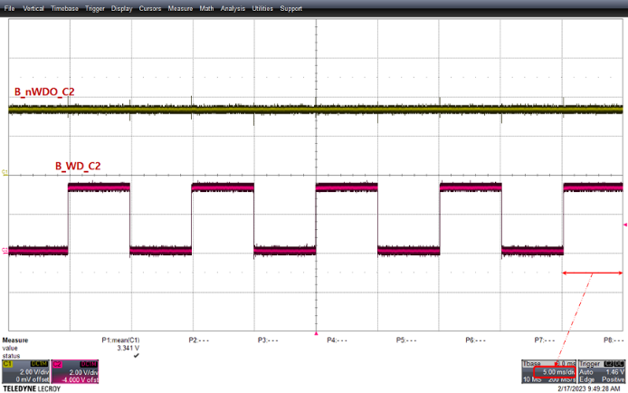 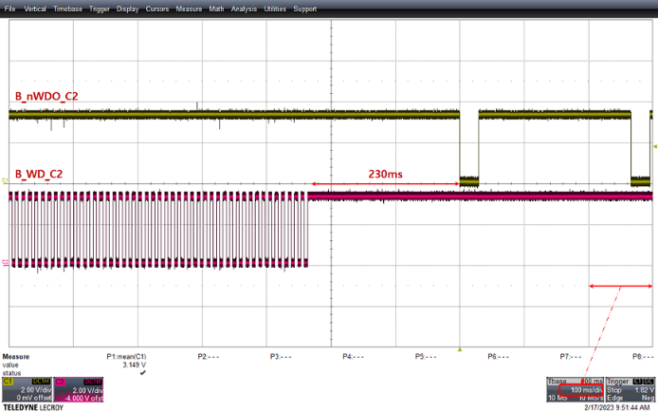~~

~~Watchdog Input Output waveform~~

* + - ~~Watchdog Period: about 10.05 [ms]~~
    - ~~Watchdog Pulse Width: 5.03[ms]~~
    - ~~Delay Watchdog Output: about 230[ms]~~

#### Test result

* + Watchdog1

|  |  |  |  |  |  |  |  |  |  |  |
| --- | --- | --- | --- | --- | --- | --- | --- | --- | --- | --- |
| **Channel** | **Component** | **Notation** | **Contents** | **Unit** | **Normal range** | | | **Measured**  **Value** | **Pass/Fail** | **Comments** |
| **Min.** | **Typ.** | **Max.** |
| Ch.1 | U5 |  | Watchdog period | ms | 9.0 | 10.0 | 11.0 | 10.05 | Pass |  |
| Watchdog Pulse  Width | ms | 4.5 | 5.0 | 5.5 | 5.02 | Pass |  |
| Delay Watchdog  Output | ms | - | 20.72 | - | 17 | Pass |  |
| Ch.2 | U7 |  | Watchdog period | ms | 9.0 | 10.0 | 11.0 | 10.07 | Pass |  |
| Watchdog Pulse  Width | ms | 4.5 | 5.0 | 5.5 | 5.03 | Pass |  |
| Delay Watchdog  Output | ms | - | 20.72 | - | 20 | Pass |  |

* + ~~Watchdog2~~

|  |  |  |  |  |  |  |  |  |  |  |
| --- | --- | --- | --- | --- | --- | --- | --- | --- | --- | --- |
| **~~Channel~~** | **~~Component~~** | **~~Notation~~** | **~~Contents~~** | **~~Unit~~** | **~~Normal range~~** | | | **~~Measured~~**  **~~Value~~** | **~~Pass/Fail~~** | **~~Comments~~** |
| **~~Min.~~** | **~~Typ.~~** | **~~Max.~~** |
| ~~Ch.1~~ | ~~U11~~ |  | ~~Watchdog period~~ | ~~ms~~ | ~~9.0~~ | ~~10.0~~ | ~~11.0~~ | ~~10.07~~ | ~~Pass~~ |  |
| ~~Watchdog Pulse~~  ~~Width~~ | ~~ms~~ | ~~4.5~~ | ~~5.0~~ | ~~5.5~~ | ~~5.04~~ | ~~Pass~~ |  |
| ~~Delay Watchdog~~  ~~Output~~ | ~~ms~~ | ~~112.0~~ | ~~200.0~~ | ~~300.0~~ | ~~230~~ | ~~Pass~~ |  |
| ~~Ch.2~~ | ~~U13~~ |  | ~~Watchdog period~~ | ~~ms~~ | ~~9.0~~ | ~~10.0~~ | ~~11.0~~ | ~~10.05~~ | ~~Pass~~ |  |
| ~~Watchdog Pulse~~  ~~Width~~ | ~~ms~~ | ~~4.5~~ | ~~5.0~~ | ~~5.5~~ | ~~5.03~~ | ~~Pass~~ |  |
| ~~Delay Watchdog~~  ~~Output~~ | ~~ms~~ | ~~112.0~~ | ~~200.0~~ | ~~300.0~~ | ~~230~~ | ~~Pass~~ |  |

#### Other confirmation test waveform

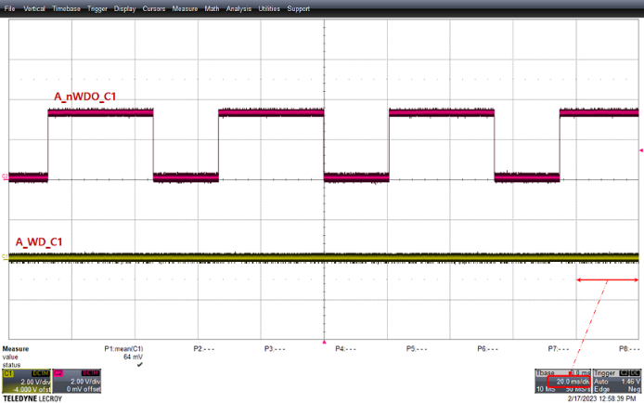 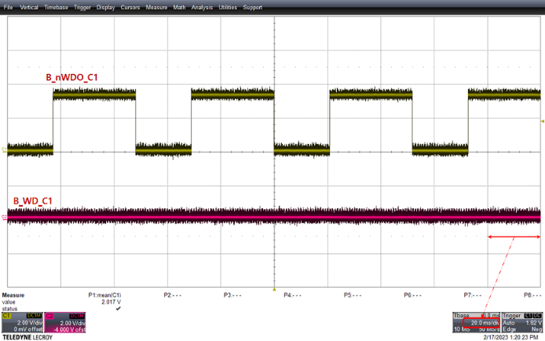

If there is no watchdog1 clock, the watchdog output waveform is as follows. It is operated with 22[ms] active low at periode 52[ms].

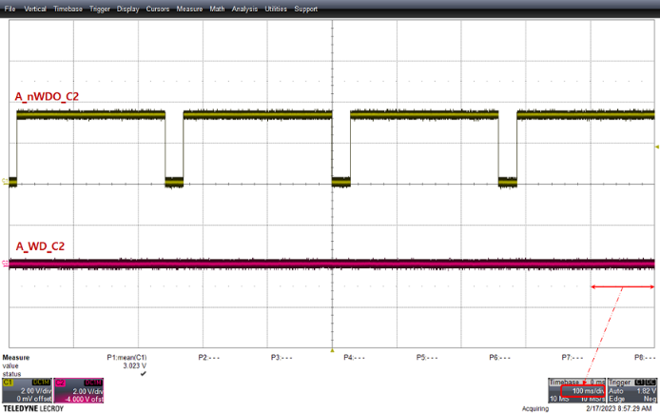 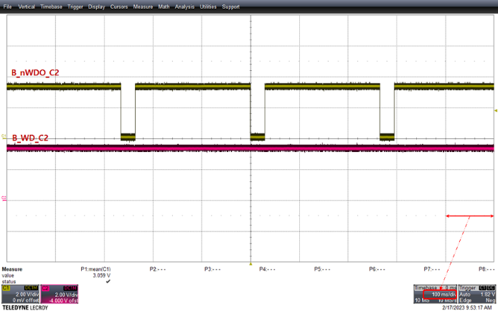

If there is no watchdog2 clock, the watchdog output waveform is as follows. It is operated with 25[ms] active low at periode 260[ms].

## Power supply function(: HF103)

### Test purpose

Check the stability of power supply for reliable system. It is also intended to refer to firmware coding for applications software.

* + - Check if the power value operates within the design value.
    - Check the power supply build-up sequence.
    - Check the operation of the under-voltage and over-voltage protection circuits of the input terminal.

### Tools

For details on the tools used for this test, refer to Chapter 2. Used Tools.

* + - Multimeter or Oscilloscope
    - Power Supply or SMPS

### Procedures

Proceed with the test according to the procedure below.

* + - Supply DC 24[V]±10% to safety controller with power supply or SMPS.
    - Measure and record voltage value in each point.
    - Also, check and record voltage value in ZYNQ(FPGA), each MCU and periperal Power.
    - Refer to FIT test about over-voltage and over-current protection in power input stage.

### Test result

#### Test condition

The test condition for the test is shown in the table below.

|  |  |  |  |  |  |
| --- | --- | --- | --- | --- | --- |
| **Ch.** | **Schematics** | **Page** | **Notation** | **Measure**  **Point** | **Temperature around**  **measuring point** |
| Ch.1 |  | 2 page | A_P24V | FB2 / 2pin | 30.7[℃] |
| 2 page | AS_P24V | EC3 / 1pin | 30.9[℃] |
|  | 3 page | AD_P3V3 | C29 / 2pin | 31.8[℃] |
| 3 page | AD_P1V2 | C38 / 2pin | 31.7[℃] |
|  | 10 page | ZP3V3 | C288 / 2pin | 34.2[℃] |
|  | 3 page | A_P5V0 | C35 / 2pin | 29.3[℃] |
| Ch.2 |  | 2 page | B_P24V | FB4 / 2pin | 30.7[℃] |
| 2 page | BS_P24V | EC3 / 1pin | 30.9[℃] |
|  | 3 page | BD_P3V3 | C48 / 2pin | 28.9[℃] |
| 3 page | BD_P1V2 | C51 / 2pin | 29.1[℃] |
|  | 2 page | B_P15V0 | EC2 / 1pin | 22.3[℃] |
| 2 page | B_N15V0 | EC5 / 2pin | 22.4[℃] |

#### Measure value

The measured voltage below is the measured voltage when the input voltage (EX_P24V & EX_24G) is 24.02[V].

|  |  |  |
| --- | --- | --- |
| **Ch.** | **Notation** | **Measured Value** |
| Ch.1 | A_P24V | 24.00[V] |
| AS_P24V | 24.00[V] |
| AD_P3V3 | 3.306[V] |
| AD_P1V2 | 1.204[V] |
| ZP3V3 | 3.305[V] |
| A_P5V0 | 4.976[V] |
| Ch.2 | B_P24V | 24.00[V] |
| BS_P24V | 24.00[V] |
| BD_P3V3 | 3.302[V] |
| BD_P1V2 | 1.203[V] |
| B_P15V0 | +15.24[V] |
| B_N15V0 | -15.48[V] |

#### Test result

|  |  |  |  |  |  |  |  |  |  |
| --- | --- | --- | --- | --- | --- | --- | --- | --- | --- |
| **Channel** | **MCU port** | **Notation** | **Contents** | **Normal range /**  **monitoring value [V]** | | | **Measured**  **Value** | **Pass/Fail** | **Comments** |
| **Min.** | **Typ.** | **Max.** |
| Ch.1 | ADCINA0 | B_P24V_AIN | Internal Ch.2 Voltage | 18.0 | 24.0 | 28.0 | Refer to  Chapter 3.5.4.2. | Pass |  |
| ADCINA1 | BS_P24V_AIN | External IO Ch.2 Voltage | 18.0 | 24.0 | 28.0 | Pass |  |
| ADCIND0 | BD_P3V3_AIN | MCU2 IO voltage | 2.97 | 3.3 | 3.63 | Pass |  |
| ADCIND1 | BD_P1V2_AIN | MCU2 core voltage | 1.08 | 1.2 | 1.32 | Pass |  |
| ADCIN14 | B_P15V0_AIN | Current sensor voltage | 13.5 | 15.0 | 16.5 | Pass |  |
| GPIO109 | B_N15V0_DIN | Current sensor voltage | -13.5 | -15.0 | -16.5 | Pass |  |
| Ch.2 | ADCINA0 | A_P24V_AIN | Internal Ch.1 Voltage | 18.0 | 24.0 | 28.0 | Pass |  |
| ADCINA1 | AS_P24V_AIN | External IO Ch.1 Voltage | 18.0 | 24.0 | 28.0 | Pass |  |
| ADCIND0 | AD_P3V3_AIN | MCU1 IO voltage | 2.97 | 3.3 | 3.63 | Pass |  |
| ADCIND1 | AD_P1V2_AIN | MCU1 core voltage | 1.08 | 1.2 | 1.32 | Pass |  |
| ADCIN14 | ZP3V3_AIN | ZynQ IO voltage | 2.97 | 3.3 | 3.63 | Pass |  |
| GPIO109 | A_P5V0_DIN | Encoder sensor voltage | 4.5 | 5.0 | 5.5 | Pass |  |

#### Other confirmation test waveform

When power is supplied by SMPS, the build-up of each power source is as follows.

* + MCU1(Ch.1) Power Build-Up

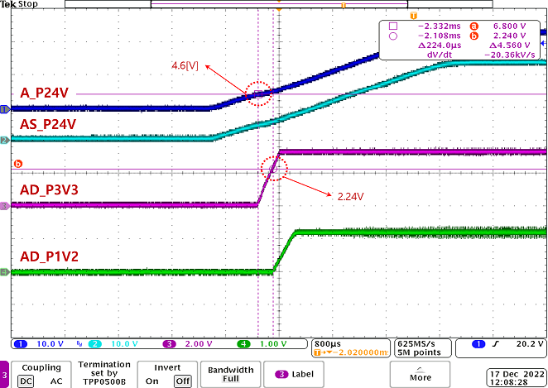

* + MCU2(Ch.2) Power Build-Up

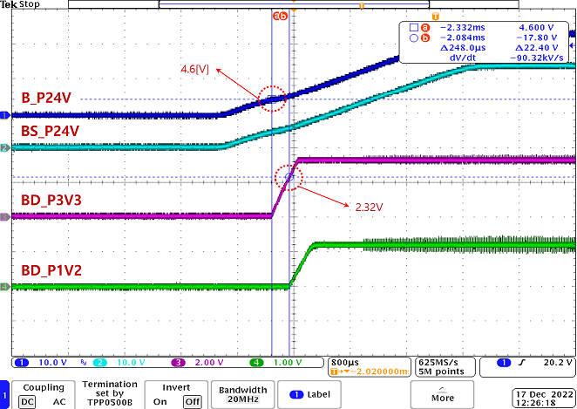

* + ZYNQ(FPGA) Power Build-Up

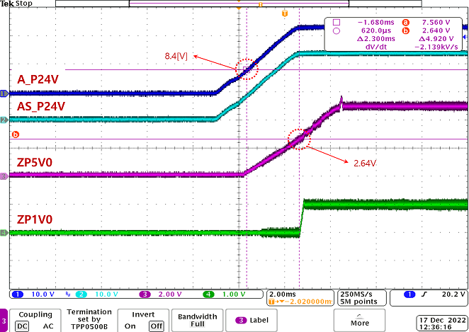 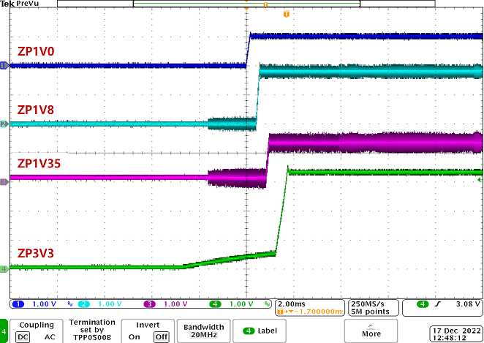

* + Current Sensor Power Build-Up

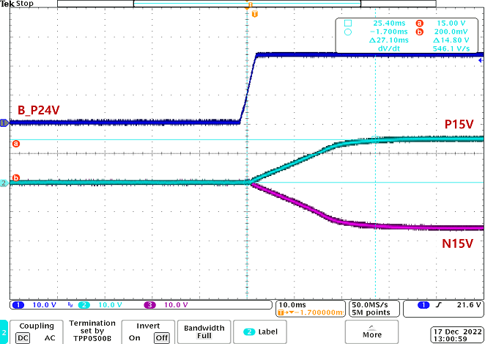

* + Encoder Power Build-Up

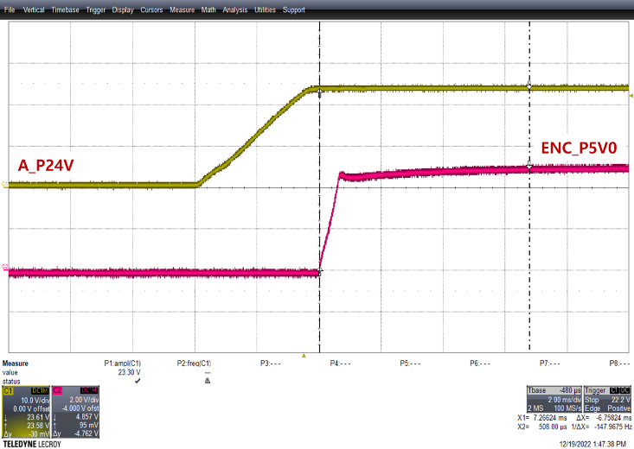

* + Under Voltage Detection

|  |  |
| --- | --- |
|  | 1Ch.(Blue): SMPS Power  2Ch.(Sky): C7 / 2pin(2page)  3Ch.(Purple): C8 / 2pin(2page)  Under Voltage Level : 16.6[V], 16.8[V] |

* + Over Voltage Detection

|  |  |
| --- | --- |
|  | 1Ch.(Blue): SMPS Power  2Ch.(Sky): C7 / 2pin(2page)  3Ch.(Purple): C8 / 2pin(2page)  Over Voltage Level : 29.5[V] |

## Encoder function(: HF104)

### Test purpose

Check the stability of encoder function by RS485 for reliable system. It is also intended to refer to firmware coding for applications software.

### Tools

For details on the tools used for this test, refer to Chapter 2. Used Tools.

* + - Oscilloscope
    - Power Supply or SMPS
    - JTAG Debugger tools for ZYNQ(FPGA)(xilinx)
    - Vivado(xilinx)
    - Encoder(tamagawa co.)

### Procedures

Proceed with the test according to the procedure below.

* + - Connect encoder and safety controller.
    - Supply DC 24[V]±10% to safety controller with power supply or SMPS.
    - Download the program for the test using the JTAG Debugger & Vivado.
    - Measure and record the transceiver pin and receiver pin of RS485 isolated communication.

### Test result

#### Test condition

The test condition for the test is shown in the table below.

|  |  |  |  |  |  |
| --- | --- | --- | --- | --- | --- |
| **Ch.** | **Schematics** | **Page** | **Notation** | **Measure**  **Point** | **Temperature around**  **measuring point** |
| ZYNQ  (FPGA) |  | 22 page | ENC_TX1 | U56 / 6pin | 30.7[℃] |
| 22 page | ENC_RX1 | U56 / 3pin | 30.9[℃] |
| - Omitted due to space.  - Similar to the picture above, only the part number  is different. | 22 page | ENC_TX2 | U58 / 6pin | 30.7[℃] |
| 22 page | ENC_RX2 | U58 / 3pin | 30.9[℃] |
| 22 page | ENC_TX3 | U60 / 6pin | 30.7[℃] |
| 22 page | ENC_RX3 | U60 / 3pin | 30.9[℃] |
| 22 page | ENC_TX4 | U62 / 6pin | 30.7[℃] |
| 22 page | ENC_RX4 | U62 / 3pin | 30.9[℃] |
| 22 page | ENC_TX5 | U57 / 6pin | 30.7[℃] |
| 22 page | ENC_RX5 | U57 / 3pin | 30.9[℃] |
| 22 page | ENC_TX6 | U59 / 6pin | 30.7[℃] |
| 22 page | ENC_RX6 | U59 / 3pin | 30.9[℃] |
| 22 page | ENC_TX7 | U61 / 6pin | 30.7[℃] |
| 22 page | ENC_RX7 | U61 / 3pin | 30.9[℃] |
| 22 page | ENC_TX8 | U63 / 6pin | 30.7[℃] |
| 22 page | ENC_RX8 | U63 / 3pin | 30.9[℃] |

#### Measure value

Data was requested to the encoder in a cycle of 200[us], and the received data at that time is shown in the waveform below.

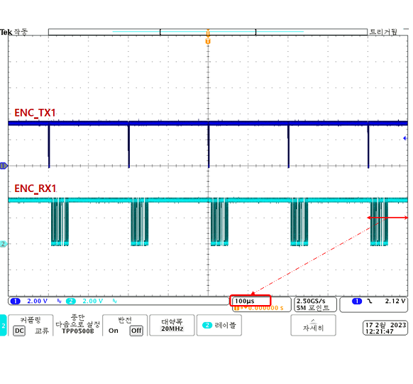 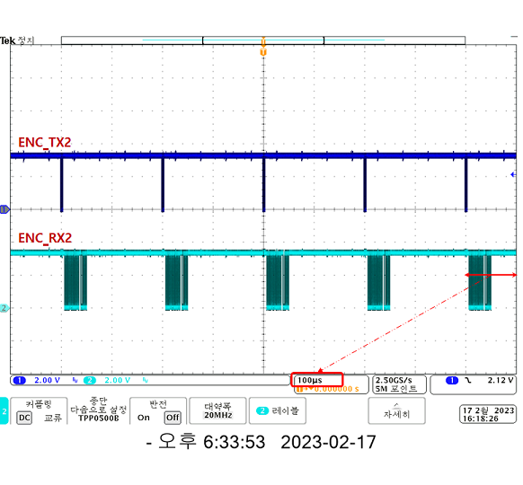

Encoder1 Encoder2

|  |  |
| --- | --- |
|  | Tamagawa encoders use the T-Format protocol. Transceiver data is a control filed and the data ID code for data acquisition is ‘3’.    - Baud rate: 2.5Mbps(0.4us) |

|  |  |
| --- | --- |
|  | Tamagawa encoders use the T-Format protocol. Receiver data is a control filed, status filed, data filed and CRC filed for ID code ‘3’.    - Baud rate: 2.5Mbps(0.4us) |

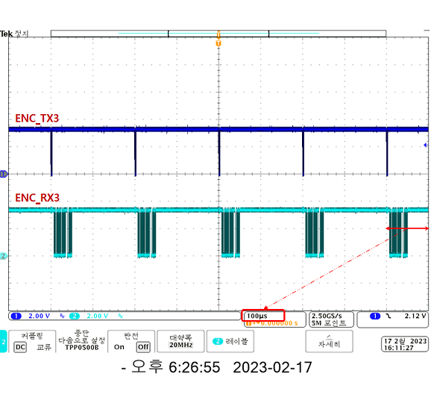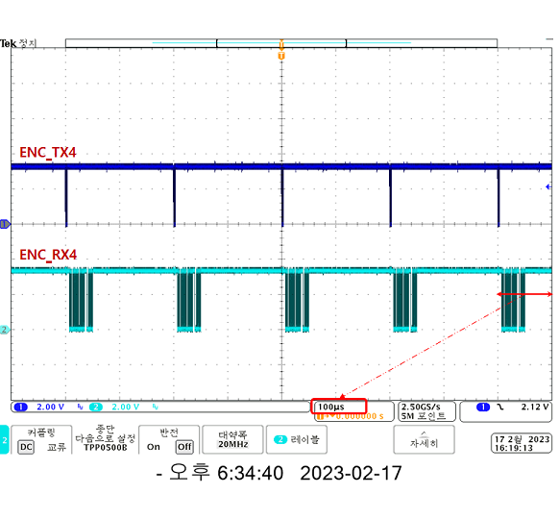

Encoder3 Encoder4

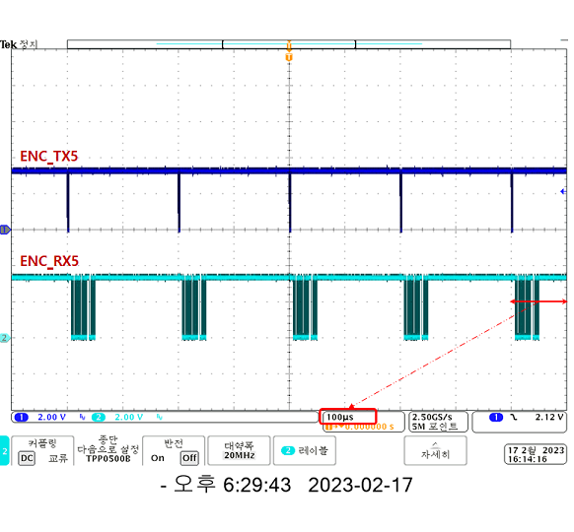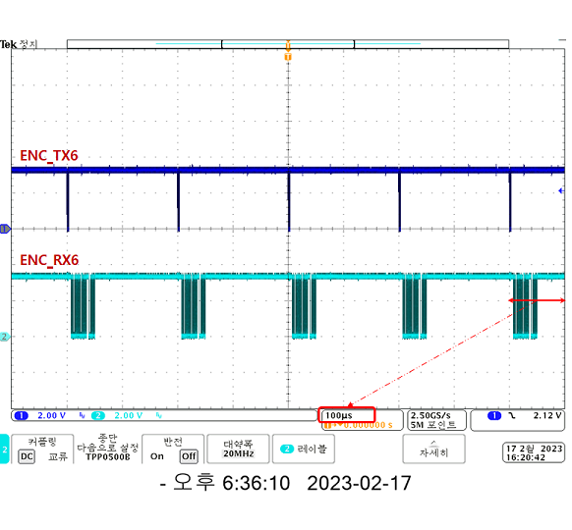

Encoder5 Encoder6

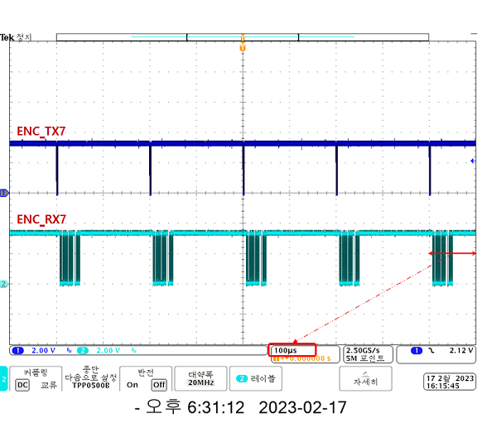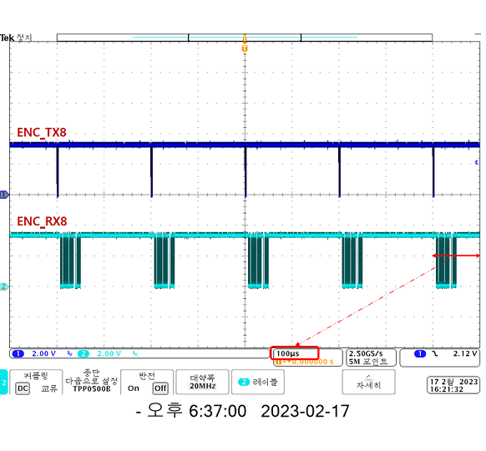

Encoder7 Encoder8

#### Test result

|  |  |  |  |  |  |  |
| --- | --- | --- | --- | --- | --- | --- |
| **Channel** | **Communication**  **ports** | **Contents** | **Criteria** | **Measured**  **Value** | **Pass/Fail** | **Comments** |
| - | CNEN13  (A2, B2 pins) | Logical Error or Fault | No Error or Fault | Refer to  Chapter 3.4.4.2. Attached Waveform | Pass |  |
| Physical waveform | Refer to RS485 standard | Pass |  |
| CNEN13  (A4, B4 pins) | Logical Error or Fault | No Error or Fault | Pass |  |
| Physical waveform | Refer to RS485 standard | Pass |  |
| CNEN13  (A6, B6 pins) | Logical Error or Fault | No Error or Fault | Pass |  |
| Physical waveform | Refer to RS485 standard | Pass |  |
| CNEN46  (A2, B2 pins) | Logical Error or Fault | No Error or Fault | Pass |  |
| Physical waveform | Refer to RS485 standard | Pass |  |
| CNEN46  (A4, B4 pins) | Logical Error or Fault | No Error or Fault | Pass |  |
| Physical waveform | Refer to RS485 standard | Pass |  |
| CNEN46  (A6, B6 pins) | Logical Error or Fault | No Error or Fault | Pass |  |
| Physical waveform | Refer to RS485 standard | Pass |  |
| CNEN7  (A2, B2 pins) | Logical Error or Fault | No Error or Fault | Pass |  |
| Physical waveform | Refer to RS485 standard | Pass |  |
| CNEN8  (A2, B2 pins) | Logical Error or Fault | No Error or Fault | Pass |  |
| Physical waveform | Refer to RS485 standard | Pass |  |

## Current sensor function(: HF105)

### Test purpose

Check the stability of ADC-related circuits (OP-AMP with gain < 1.0, ADC reference voltage and etc) for for reliable system. It is also intended to refer to firmware coding for applications software.

### Tools

For details on the tools used for this test, refer to Chapter 2. Used Tools.

* + - Oscilloscope
    - Power Supply or SMPS
    - Function Generator
    - Test zig Board
    - Multimeter

### Procedures

Proceed with the test according to the procedure below.

* + - Supply DC 24[V]±10% to safety controller with power supply or SMPS.
    - Measure and record the ADC reference voltage using a multimeter.
    - Supply simulated signals(±10[V]/120[Hz]) using a Function Generator and a Test zig Board.
    - Measure and record the ADC input waveform.

### Test result

#### Test condition

The test condition for the test is shown in the table below.

* + ADC Reference voltage

|  |  |  |  |  |  |
| --- | --- | --- | --- | --- | --- |
| **Ch.** | **Schematics** | **Page** | **Notation** | **Measure**  **Point** | **Temperature around**  **measuring point** |
| Ch.1 |  | 5 page | AA_P3V0 | C118 / 2pin | 39.7[℃] |
|  | 20 page | AA_P1V5_0 | C708 / 1pin | 30.8[℃] |
|  | AA_P1V5_1 | C709 / 1pin | 30.8[℃] |
| Ch.2 |  | 5 page | BA_P3V0 | C139 / 2pin | 39.7[℃] |
|  | 20 page | BA_P1V5_0 | C710 / 1pin | 32.2[℃] |
|  | BA_P1V5_1 | C709 / 1pin | 32.1[℃] |

* + ADC Input waveform

|  |  |  |  |  |  |
| --- | --- | --- | --- | --- | --- |
| **Ch.** | **Schematics** | **Page** | **Notation** | **Measure**  **Point** | **Temperature around**  **measuring point** |
| Ch.1 |  | 18 page | A_IUN1 | R523 / 2pin | 30.1[℃] |
| - Omitted due to space.  - Similar to the picture above, only the part number  is different. | A_IVN1 | R550 / 2pin | 29.8[℃] |
| A_IUN2 | R569 / 2pin | 29.8[℃] |
| A_IVN2 | R591 / 2pin | 30.2[℃] |
| A_IUN3 | R528 / 2pin | 27.2[℃] |
| A_IVN3 | R547 / 2pin | 26.9[℃] |
| A_IUN4 | R565 / 2pin | 26.8[℃] |
| A_IVN4 | R593 / 2pin | 27.1[℃] |
| A_IUN5 | R535 / 2pin | 34.4[℃] |
| A_IVN5 | R556 / 2pin | 32.7[℃] |
| A_IUN6 | R577 / 2pin | 32.6[℃] |
| A_IVN6 | R598 / 2pin | 32.6[℃] |
| 19 page | A_IUN7 | R607 / 2pin | 28.3[℃] |
| A_IVN7 | R628 / 2pin | 26.8[℃] |
| A_IUN8 | R654 / 2pin | 26.9[℃] |
| A_IVN8 | R679 / 2pin | 28.4[℃] |
| Ch.2 |  | 19 page | B_IVN1 | R616 / 2pin | 29.2[℃] |
| - Omitted due to space.  - Similar to the picture above, only the part number  is different. | B_IWN1 | R632 / 2pin | 29.0[℃] |
| B_IVN2 | R650 / 2pin | 29.1[℃] |
| B_IWN2 | R674 / 2pin | 28.9[℃] |
| B_IVN3 | R619 / 2pin | 23.9[℃] |
| B_IWN3 | R640 / 2pin | 23.6[℃] |
| B_IVN4 | R661 / 2pin | 23.8[℃] |
| B_IWN4 | R682 / 2pin | 24.0[℃] |
| 20 page | B_IVN5 | R695 / 2pin | 32.2[℃] |
| B_IWN5 | R710 / 2pin | 32.0[℃] |
| B_IVN6 | R729 / 2pin | 32.3[℃] |
| B_IWN6 | R743 / 2pin | 32.1[℃] |
| B_IVN7 | R698 / 2pin | 25.3[℃] |
| B_IWN7 | R713 / 2pin | 25.1[℃] |
| B_IVN8 | R733 / 2pin | 25.3[℃] |
| B_IWN8 | R750 / 2pin | 25.1[℃] |

#### Measure value

* + ADC Reference voltage

|  |  |  |
| --- | --- | --- |
| **Ch.** | **Notation** | **Measured Value** |
| Ch.1 | AA_P3V0 | 3.001[V] |
| AA_P1V5_0 | 1.503[V] |
| AA_P1V5_1 | 1.502[V] |
| Ch.2 | BA_P3V0 | 3.000[V] |
| BA_P1V5_0 | 1.502[V] |
| BA_P1V5_1 | 1.501[V] |

* + ADC Input waveform

|  |  |
| --- | --- |
|  | - 1ch.(Blue Color): Simulated Signal  - 2ch.(Sky Color): Measured Signal |

Simulated Signal

* + - Frequency: 8.334[ms] (almost 120Hz)
    - Min/Max Voltage: -10.0[V](Min), +10.0[V](Max)

Measured Signal

* + - Frequency: 8.334[ms] (almost 120Hz)
    - Min/Max Voltage: 0.0[V](Min), +3.0[V](Max)
    - Delay Time: 5.0[ns] (Check Point 1.5[V])

|  |  |
| --- | --- |
|  | - A_IUN1: Top-Left |
| - A_IVN1: Top-Right |
| - A_IUN2: Bottom-Left |
| - A_IVN2: Bottom-Right |

|  |  |
| --- | --- |
|  | - A_IUN3: Top-Left |
| - A_IVN3: Top-Right |
| - A_IUN4: Bottom-Left |
| - A_IVN4: Bottom-Right |

|  |  |
| --- | --- |
|  | - A_IUN5: Top-Left |
| - A_IVN5: Top-Right |
| - A_IUN6: Bottom-Left |
| - A_IVN6: Bottom-Right |

|  |  |
| --- | --- |
|  | - A_IUN7: Top-Left |
| - A_IVN7: Top-Right |
| - A_IUN8: Bottom-Left |
| - A_IVN8: Bottom-Right |

|  |  |
| --- | --- |
|  | - B_IVN1: Top-Left |
| - B_IWN1: Top-Right |
| - B_IVN2: Bottom-Left |
| - B_IWN2: Bottom-Right |

|  |  |
| --- | --- |
|  | - B_IVN3: Top-Left |
| - B_IWN3: Top-Right |
| - B_IVN4: Bottom-Left |
| - B_IWN4: Bottom-Right |

|  |  |
| --- | --- |
|  | - B_IVN5: Top-Left |
| - B_IWN5: Top-Right |
| - B_IVN6: Bottom-Left |
| - B_IWN6: Bottom-Right |

|  |  |
| --- | --- |
|  | - B_IVN7: Top-Left |
| - B_IWN7: Top-Right |
| - B_IVN8: Bottom-Left |
| - B_IWN8: Bottom-Right |

#### Test result

|  |  |  |  |  |  |  |  |
| --- | --- | --- | --- | --- | --- | --- | --- |
| **Channel** | **MCU port** | **Notation** | **Contents** | **Normal range value**  **Analog Signal** | **Measured**  **Value** | **Pass/Fail** | **Comments** |
| Ch.1 | ADCINA2 | A_IUN1 | Motor1 U-phase current | 0.0 ~ 3.0[V],  120[Hz] | Refer to Chapter 3.5.4.2. Attached Waveform | Pass |  |
| ADCINA3 | A_IVN1 | Motor1 V-phase current | Pass |  |
| ADCINA4 | A_IUN2 | Motor2 U-phase current | Pass |  |
| ADCINA5 | A_IVN2 | Motor2 V-phase current | Pass |  |
| ADCINB2 | A_IUN3 | Motor3 U-phase current | Pass |  |
| ADCINB3 | A_IVN3 | Motor3 V-phase current | Pass |  |
| ADCINB4 | A_IUN4 | Motor4 U-phase current | Pass |  |
| ADCINB5 | A_IVN4 | Motor4 V-phase current | Pass |  |
| ADCINC2 | A_IUN5 | Motor5 U-phase current | Pass |  |
| ADCINC3 | A_IVN5 | Motor5 V-phase current | Pass |  |
| ADCINC4 | A_IUN6 | Motor6 U-phase current | Pass |  |
| ADCINC5 | A_IVN6 | Motor6 V-phase current | Pass |  |
| ADCIND2 | A_IUN7 | Motor7 U-phase current | Pass |  |
| ADCIND3 | A_IVN7 | Motor7 V-phase current | Pass |  |
| ADCIND4 | A_IUN8 | Motor8 U-phase current | Pass |  |
| ADCIND5 | A_IVN8 | Motor8 V-phase current | Pass |  |
| Ch.2 | ADCINA2 | B_IVN1 | Motor1 V-phase current | 0.0 ~ 3.0[V],  120[Hz] | Pass |  |
| ADCINA3 | B_IWN1 | Motor1 W-phase current | Pass |  |
| ADCINA4 | B_IVN2 | Motor2 V-phase current | Pass |  |
| ADCINA5 | B_IWN2 | Motor2 W-phase current | Pass |  |
| ADCINB2 | B_IVN3 | Motor3 V-phase current | Pass |  |
| ADCINB3 | B_IWN3 | Motor3 W-phase current | Pass |  |
| ADCINB4 | B_IVN4 | Motor4 V-phase current | Pass |  |
| ADCINB5 | B_IWN4 | Motor4 W-phase current | Pass |  |
| ADCINC2 | B_IVN5 | Motor5 V-phase current | Pass |  |
| ADCINC3 | B_IWN5 | Motor5 W-phase current | Pass |  |
| ADCINC4 | B_IVN6 | Motor6 V-phase current | Pass |  |
| ADCINC5 | B_IWN6 | Motor6 W-phase current | Pass |  |
| ADCIND2 | B_IVN7 | Motor7 V-phase current | Pass |  |
| ADCIND3 | B_IWN7 | Motor7 W-phase current | Pass |  |
| ADCIND4 | B_IVN8 | Motor8 V-phase current | Pass |  |
| ADCIND5 | B_IWN8 | Motor8 W-phase current | Pass |  |

## Safety input function(: HF106)

### Test purpose

Check the stability of safety input circuits for for reliable system. It is also intended to refer to firmware coding for applications software.

* + - Check the hardware input/output delay time to implement safety input functions such as test pulse.
    - In order to stably implement safety input signal processing, the phase difference of the input signal between channel 1 & 2 is checked.

### Tools

For details on the tools used for this test, refer to Chapter 2. Used Tools.

* + - Oscilloscope
    - Power Supply or SMPS
    - JTAG Debugger
    - Code Composer Studio
    - RS232toUSB Converter
    - Monitoring and Control Interface

### Procedures

Proceed with the test according to the procedure below.

* + - Supply DC 24[V]±10% to safety controller with power supply or SMPS.
    - Download the program for the test using the JTAG Debugger & Code Composer Studio.
    - Turn ON/OFF the signal correspoding to the safety input function using the RS232toUSB Converter & Monitoring and Control Interface.
    - Measure and record the voltage corresponding to each safety intput function.

### Test result

#### Test condition

The test condition for the test is shown in the table below.

* + Operation Panel Emergency Switch

|  |  |  |  |  |  |
| --- | --- | --- | --- | --- | --- |
| **Ch.** | **Schematics** | **Page** | **Notation** | **Measure**  **Point** | **Temperature around**  **measuring point** |
| Ch.1 |  | 15 page | A_nOPEM_T  A_nOPEM_T_FDK  A_OPEM_T | R365 / 1pin  R374 / 2pin  D18 / Cpin | [℃] |
| Ch.2 |  | 15 page | B_nOPEM_T  B_nOPEM_T_FDK  B_OPEM_T | R384 / 1pin  R396 / 2pin  D21 / Cpin | [℃] |

* + T/P Interface Input Signal

|  |  |  |  |  |  |
| --- | --- | --- | --- | --- | --- |
| **Ch.** | **Schematics** | **Page** | **Notation** | **Measure**  **Point** | **Temperature around**  **measuring point** |
| Ch.1 |  | 15 page | A_nTPEM1_T  A_nTPEM1_T_FDK  A_TPEM1_T | R363 / 1pin  R371 / 2pin  D16 / Cpin | [℃] |
| - Omitted due to space.  - Similar to the picture above, only the part  number is different. | A_nTPEN1_T  A_nTPEN1_T_FDK  A_TPEN1_T | R386 / 1pin  R394 / 2pin  D19 / Cpin | [℃] |
|  | TP_RMT  A_nTPRMT | R400 / 2pin  R402 / 2pin | [℃] |
| - Omitted due to space.  - Similar to the picture above, only the part  number is different. | TP_MAN  A_nTPMAN | R410 / 2pin  R408 / 2pin | [℃] |
| TP_AUTO  A_nTPAUTO | R412 / 2pin  R414 / 2pin | [℃] |
| Ch.2 |  | 15 page | B_nTPEM1_T  B_nTPEM1_T_FDK  B_TPEM1_T | R362 / 1pin  R373 / 2pin  D17 / Cpin | [℃] |
| - Omitted due to space.  - Similar to the picture above, only the part  number is different. | B_nTPEN1_T  B_nTPEN1_T_FDK  B_TPEN1_T | R385 / 1pin  R395 / 2pin  D20 / Cpin | [℃] |
|  | TP_RMT  B_nTPRMT | R400 / 2pin  R403 / 2pin | [℃] |
| - Omitted due to space.  - Similar to the picture above, only the part  number is different. | TP_MAN  B_nTPMAN | R410 / 2pin  R409 / 2pin | [℃] |
| TP_AUTO  B_nTPAUTO | R412 / 2pin  R415 / 2pin | [℃] |

* + General Safety Input Signal

|  |  |  |  |  |  |
| --- | --- | --- | --- | --- | --- |
| **Ch.** | **Schematics** | **Page** | **Notation** | **Measure**  **Point** | **Temperature around**  **measuring point** |
| Ch.1 |  | 16 page | A_nSI1_T  A_SI1_P  A_nSI1 | R423 / 1pin  R419 / 2pin  R433 / 2pin | 39.7[℃] |
| - Omitted due to space.  - Similar to the picture above, only the part  number is different. | A_nSI2_T  A_SI2_P  A_nSI2 | R424 / 1pin  R425 / 2pin  R434 / 2pin | 39.7[℃] |
| A_nSI3_T  A_SI3_P  A_nSI3 | R426 / 1pin  R422 / 2pin  R435 / 2pin | 39.7[℃] |
| 17 page | A_nSI4_T  A_SI4_P  A_nSI4 | R474 / 1pin  R473 / 2pin  R485 / 2pin | 39.7[℃] |
| Ch.2 |  | 16 page | B_nSI1_T  B_SI1_P  B_nSI1 | R445 / 1pin  R446 / 2pin  R456 / 2pin | 39.7[℃] |
| - Omitted due to space.  - Similar to the picture above, only the part  number is different. | B_nSI2_T  B_SI2_P  B_nSI2 | R449 / 1pin  R443 / 2pin  R458 / 2pin | 39.7[℃] |
| B_nSI3_T  B_SI3_P  B_nSI3 | R450 / 1pin  R444 / 2pin  R459 / 2pin | 39.7[℃] |
| 17 page | B_nSI4_T  B_SI4_P  B_nSI4 | R498 / 1pin  R497 / 2pin  R507 / 2pin | 39.7[℃] |

* + Optional Safety Input Signal

|  |  |  |  |  |  |
| --- | --- | --- | --- | --- | --- |
| **Ch.** | **Schematics** | **Page** | **Notation** | **Measure**  **Point** | **Temperature around**  **measuring point** |
| Ch.1 |  | 4 page | A_SI1  A_nSI1 | CNSI2 / 1pin  PC5 / 16 pin | 39.7[℃] |
| - Omitted due to space.  - Similar to the picture above, only the part  number is different. | A_SI2  A_nSI2 | CNSI2 / 3pin  PC5 / 14 pin |  |
| A_SI3  A_nSI3 | CNSI2 / 5pin  PC5 / 12 pin |  |
| A_SI4  A_nSI4 | CNSI2 / 7pin  PC5 / 10 pin |  |
| A_SI5  A_nSI5 | CNSI2 / 9pin  PC6 / 16 pin |  |
| A_SI6  A_nSI6 | CNSI2 / 11pin  PC6 / 14 pin |  |
| A_SI7  A_nSI7 | CNSI2 / 13pin  PC6 / 12 pin |  |
| A_SI8  A_nSI8 | CNSI2 / 15pin  PC6 / 10 pin |  |
| Ch.2 |  | 4 page | B_SI1  B_nSI1 | CNSI2 / 2pin  PC7 / 16 pin | 39.7[℃] |
| - Omitted due to space.  - Similar to the picture above, only the part  number is different. | B_SI2  B_nSI2 | CNSI2 / 4pin  PC7 / 14 pin |  |
| B_SI3  B_nSI3 | CNSI2 / 6pin  PC7 / 12 pin |  |
| B_SI4  B_nSI4 | CNSI2 / 8pin  PC7 / 10 pin |  |
| B_SI5  B_nSI5 | CNSI2 / 10pin  PC8 / 16 pin |  |
| B_SI6  B_nSI6 | CNSI2 / 12pin  PC8 / 14 pin |  |
| B_SI7  B_nSI7 | CNSI2 / 14pin  PC8 / 12 pin |  |
| B_SI8  B_nSI8 | CNSI2 / 16pin  PC8 / 10 pin |  |

#### Measure value

##### Operation Panel Emergency Switch

|  |  |
| --- | --- |
|  | Cable length: 1.0[m] |

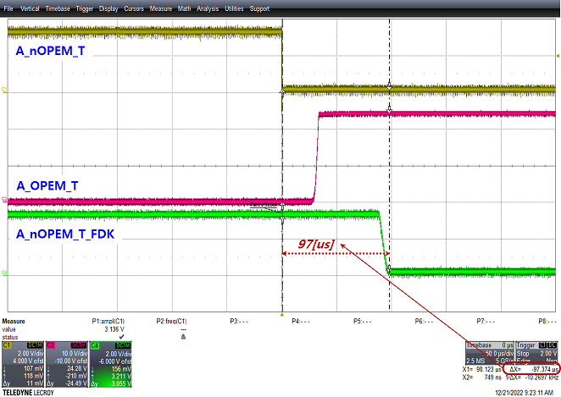 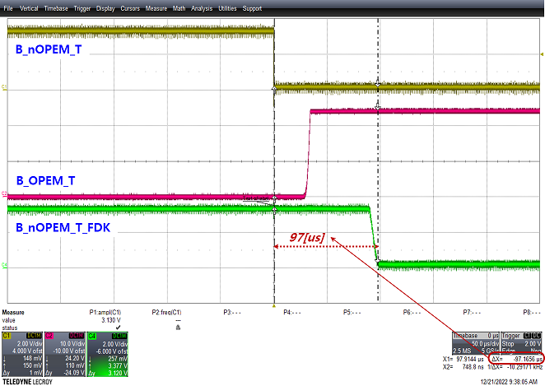

Waveform at the point of ON of the test pulse signal in the state of emergency stop switch connection.

* + - Delay time of test pulse feedback for each channel: 97.0[us]

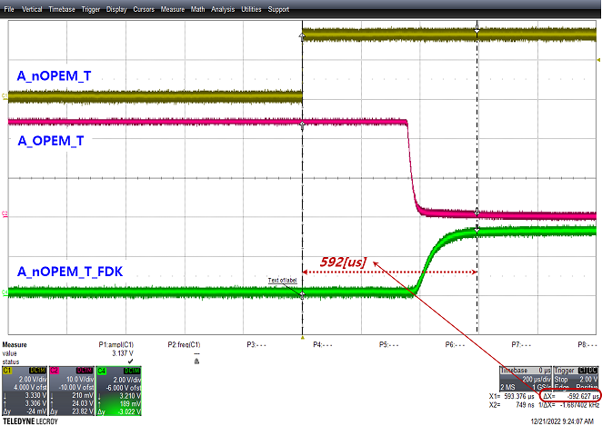 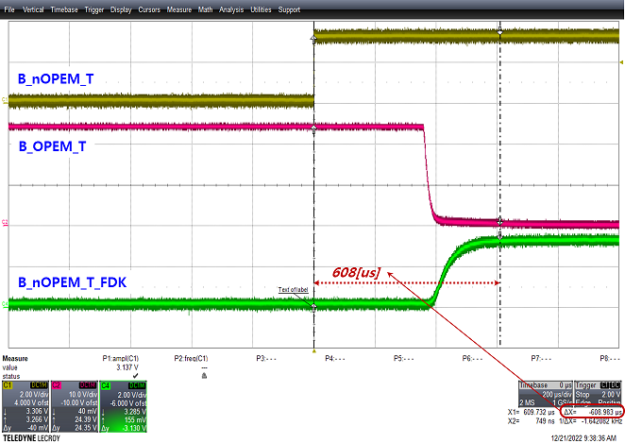

Waveform at the point of OFF of the test pulse signal in the state of emergency stop switch connection.

* + - Delay time of test pulse feedback for each channel: 592[us](Ch.1), 608[us](Ch.2)

*The delay time for each channel when operating the emergency stop switch is handled by the operation of the T/P emergency stop switch (generally, this is because the T/P cable is long).*

##### T/P Interface Input Signal

|  |  |
| --- | --- |
|  | Cable length: 40.0[m] |

* Test of test pulse ON/OFF (Emergency switch of T/P)

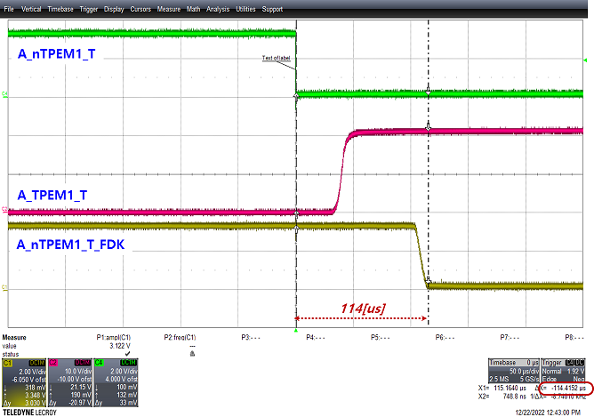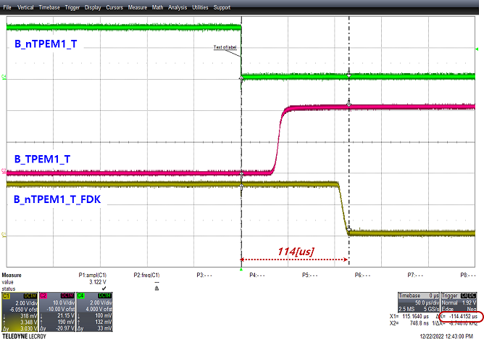

Waveform at the point of ON of the test pulse signal in the state of emergency stop switch connection.

* + - Delay time of test pulse feedback for each channel: 114[us]

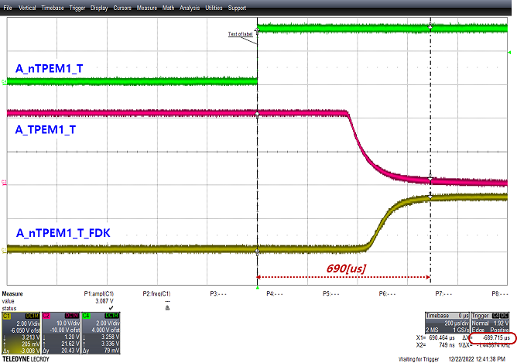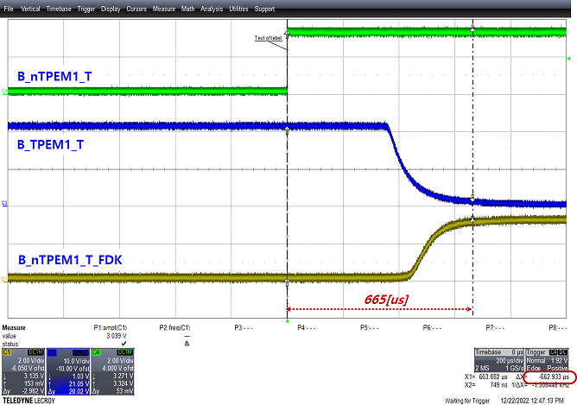

Waveform at the point of OFF of the test pulse signal in the state of emergency stop switch connection.

* + - Delay time of test pulse feedback for each channel: 690[us](Ch.1), 665[us](Ch.2)
* Test of emergency switch push/pull (Emergency switch of T/P)

|  |  |
| --- | --- |
|  | Test of push   * + - A_nTPEM1_T=Low     - B_nTPEM1_T=Low |

|  |  |
| --- | --- |
|  | Test of pull   * + - A_nTPEM1_T=Low     - B_nTPEM1_T=Low |

* Test of test pulse ON/OFF (Enable switch of T/P)

Since the enable switch operates only in manual mode, a separate test pulse test is not performed.

* Test of enable switch push/pull (Enable switch of T/P)

|  |  |
| --- | --- |
|  | Test of push   * + - A_nTPEN1_T=Low     - B_nTPEN1_T=Low |

|  |  |
| --- | --- |
|  | Test of pull   * + - A_nTPEM1_T=Low     - B_nTPEM1_T=Low |

* Test of Remote ON/OFF (Remote of T/P)

|  |  |
| --- | --- |
|  | Test of ON |

|  |  |
| --- | --- |
|  | Test of OFF |

* Test of Auto ON/OFF (Auto of T/P)

|  |  |
| --- | --- |
|  | Test of ON |

|  |  |
| --- | --- |
|  | Test of OFF |

* Test of Manual ON/OFF (Manual of T/P)

|  |  |
| --- | --- |
|  | Test of ON |

|  |  |
| --- | --- |
|  | Test of OFF |

##### General Safety Input Signal

* + - Test of SI1 ON/OFF

|  |  |
| --- | --- |
| Test of ON  - A_SI1_P is ‘H(:AS_P24V)’  - A_nSI1 is ‘L(:A_DG)’  - B_SI1_P is ‘H(:BS_P24V)’  - B_nSI1 is ‘L(:B_DG)’ | Test of OFF  - A_SI1_P is ‘H(:AS_G)’  - A_nSI1 is ‘L(:AD_P3V3)’  - B_SI1_P is ‘H(:BS_G)’  - B_nSI1 is ‘L(:BD_P3V3)’ |

* + - Test of SI1 test pulse signal ON/OFF

|  |  |
| --- | --- |
| Test of test pulse signal ON  - A_nSI1_T is ‘L(:A_DG)’  - A_nSI1 is ‘H(:AD_P3V3)’  - B_nSI1_T is ‘L(:B_DG)’  - B_nSI1 is ‘H(:BD_P3V3)’  Delay time: about 100[us] | Test of test pulse signal OFF  - A_nSI1_T is ‘H(:AD_P3V3)’  - A_nSI1 is ‘L(:A_DG)’  - B_nSI1_T is ‘H(:BD_P3V3)’  - B_nSI1 is ‘L(:B_DG)’  Delay Time: about 83[us] |

* + - Test of SI2 ON/OFF

|  |  |
| --- | --- |
| Test of ON  - A_SI2_P is ‘H(:AS_P24V)’  - A_nSI2 is ‘L(:A_DG)’  - B_SI2_P is ‘H(:BS_P24V)’  - B_nSI2 is ‘L(:B_DG)’ | Test of OFF  - A_SI2_P is ‘H(:AS_G)’  - A_nSI2 is ‘L(:AD_P3V3)’  - B_SI2_P is ‘H(:BS_G)’  - B_nSI2 is ‘L(:BD_P3V3)’ |

* + - Test of SI2 test pulse signal ON/OFF

|  |  |
| --- | --- |
|  |  |
| Test of test pulse signal ON  - A_nSI2_T is ‘L(:A_DG)’  - A_nSI2 is ‘H(:AD_P3V3)’  - B_nSI2_T is ‘L(:B_DG)’  - B_nSI2 is ‘H(:BD_P3V3)’  Delay time: about 100[us] | Test of test pulse signal OFF  - A_nSI2_T is ‘H(:AD_P3V3)’  - A_nSI2 is ‘L(:A_DG)’  - B_nSI2_T is ‘H(:BD_P3V3)’  - B_nSI2 is ‘L(:B_DG)’  Delay Time: about 83[us] |

* + - Test of SI3 ON/OFF

|  |  |
| --- | --- |
| Test of ON  - A_SI3_P is ‘H(:AS_P24V)’  - A_nSI3 is ‘L(:A_DG)’  - B_SI3_P is ‘H(:BS_P24V)’  - B_nSI3 is ‘L(:B_DG)’ | Test of OFF  - A_SI3_P is ‘H(:AS_G)’  - A_nSI3 is ‘L(:AD_P3V3)’  - B_SI3_P is ‘H(:BS_G)’  - B_nSI3 is ‘L(:BD_P3V3)’ |

* + - Test of SI3 test pulse signal ON/OFF

|  |  |
| --- | --- |
| Test of test pulse signal ON  - A_nSI3_T is ‘L(:A_DG)’  - A_nSI3 is ‘H(:AD_P3V3)’  - B_nSI3_T is ‘L(:B_DG)’  - B_nSI3 is ‘H(:BD_P3V3)’  Delay time: about 100[us] | Test of test pulse signal OFF  - A_nSI3_T is ‘H(:AD_P3V3)’  - A_nSI3 is ‘L(:A_DG)’  - B_nSI3_T is ‘H(:BD_P3V3)’  - B_nSI3 is ‘L(:B_DG)’  Delay Time: about 83[us] |

* + - Test of SI4 ON/OFF

|  |  |
| --- | --- |
| Test of ON  - A_SI4_P is ‘H(:AS_P24V)’  - A_nSI4 is ‘L(:A_DG)’  - B_SI4_P is ‘H(:BS_P24V)’  - B_nSI4 is ‘L(:B_DG)’ | Test of OFF  - A_SI4_P is ‘H(:AS_G)’  - A_nSI4 is ‘L(:AD_P3V3)’  - B_SI4_P is ‘H(:BS_G)’  - B_nSI4 is ‘L(:BD_P3V3)’ |

* + - Test of SI4 test pulse signal ON/OFF

|  |  |
| --- | --- |
| Test of test pulse signal ON  - A_nSI4_T is ‘L(:A_DG)’  - A_nSI4 is ‘H(:AD_P3V3)’  - B_nSI4_T is ‘L(:B_DG)’  - B_nSI4 is ‘H(:BD_P3V3)’  Delay time: about 100[us] | Test of test pulse signal OFF  - A_nSI4_T is ‘H(:AD_P3V3)’  - A_nSI4 is ‘L(:A_DG)’  - B_nSI4_T is ‘H(:BD_P3V3)’  - B_nSI4 is ‘L(:B_DG)’  Delay time: about 83[us] |

##### Optional Safety Input Signal

* + - Test of optional SI1 ON/OFF

|  |  |
| --- | --- |
| Test of ON  - A_SI1 is ‘H(:A24V)’  - A_nSI1 is ‘L(:AG)’  - B_SI1 is ‘L(:BG)’  - B_nSI1 is ‘L(:BG)’ | Test of OFF  - A_SI1 is ‘L(:AG)’  - A_nSI1 is ‘H(:A3V3)’  - B_SI1 is ‘H(:B24V)’  - B_nSI1 is ‘H(:B3V3)’ |

* + - Test of optional SI2 ON/OFF

|  |  |
| --- | --- |
| Test of ON  - A_SI2 is ‘H(:A24V)’  - A_nSI2 is ‘L(:AG)’  - B_SI2 is ‘L(:BG)’  - B_nSI2 is ‘L(:BG)’ | Test of OFF  - A_SI2 is ‘L(:AG)’  - A_nSI2 is ‘H(:A3V3)’  - B_SI2 is ‘H(:B24V)’  - B_nSI2 is ‘H(:B3V3)’ |

* + - Test of optional SI3 ON/OFF

|  |  |
| --- | --- |
| Test of ON  - A_SI3 is ‘H(:A24V)’  - A_nSI3 is ‘L(:AG)’  - B_SI3 is ‘L(:BG)’  - B_nSI3 is ‘L(:BG)’ | Test of OFF  - A_SI3 is ‘L(:AG)’  - A_nSI3 is ‘H(:A3V3)’  - B_SI3 is ‘H(:B24V)’  - B_nSI3 is ‘H(:B3V3)’ |

* + - Test of optional SI4 ON/OFF

|  |  |
| --- | --- |
| Test of ON  - A_SI4 is ‘H(:A24V)’  - A_nSI4 is ‘L(:AG)’  - B_SI4 is ‘L(:BG)’  - B_nSI4 is ‘L(:BG)’ | Test of OFF  - A_SI4 is ‘L(:AG)’  - A_nSI4 is ‘H(:A3V3)’  - B_SI4 is ‘H(:B24V)’  - B_nSI4 is ‘H(:B3V3)’ |

* + - Test of optional SI5 ON/OFF

|  |  |
| --- | --- |
| Test of ON  - A_SI5 is ‘H(:A24V)’  - A_nSI5 is ‘L(:AG)’  - B_SI5 is ‘L(:BG)’  - B_nSI5 is ‘L(:BG)’ | Test of OFF  - A_SI5 is ‘L(:AG)’  - A_nSI5 is ‘H(:A3V3)’  - B_SI5 is ‘H(:B24V)’  - B_nSI5 is ‘H(:B3V3)’ |

* + - Test of optional SI6 ON/OFF

|  |  |
| --- | --- |
| Test of ON  - A_SI6 is ‘H(:A24V)’  - A_nSI6 is ‘L(:AG)’  - B_SI6 is ‘L(:BG)’  - B_nSI6 is ‘L(:BG)’ | Test of OFF  - A_SI6 is ‘L(:AG)’  - A_nSI6 is ‘H(:A3V3)’  - B_SI6 is ‘H(:B24V)’  - B_nSI6 is ‘H(:B3V3)’ |

* + - Test of optional SI7 ON/OFF

|  |  |
| --- | --- |
| Test of ON  - A_SI7 is ‘H(:A24V)’  - A_nSI7 is ‘L(:AG)’  - B_SI7 is ‘L(:BG)’  - B_nSI7 is ‘L(:BG)’ | Test of OFF  - A_SI7 is ‘L(:AG)’  - A_nSI7 is ‘H(:A3V3)’  - B_SI7 is ‘H(:B24V)’  - B_nSI7 is ‘H(:B3V3)’ |

* + - Test of optional SI8 ON/OFF

|  |  |
| --- | --- |
| Test of ON  - A_SI8 is ‘H(:A24V)’  - A_nSI8 is ‘L(:AG)’  - B_SI8 is ‘L(:BG)’  - B_nSI8 is ‘L(:BG)’ | Test of OFF  - A_SI8 is ‘L(:AG)’  - A_nSI8 is ‘H(:A3V3)’  - B_SI8 is ‘H(:B24V)’  - B_nSI8 is ‘H(:B3V3)’ |

#### Test result

In this test, it is a value measured by a single module board. After mounting on the actual robot controller, additional tests and software must be performed and applied.

| **Type** | **Name** | **Usage** | **Contents** | **Normal status** | **Measured**  **Value** | **Pass/Fail** | **Comments** |
| --- | --- | --- | --- | --- | --- | --- | --- |
| Type.1.  BD642A | A_OPEM1 | Emergency Stop  input(Ch.1) | Push ON(Open) | A_nOPEM1_T_FDK = HIGH | Refer to  Chapter  3.6.4.2.  Attached  Waveform | Pass |  |
| Push OFF(Close) | A_nOPEM1_T_FDK =  A_nOPEM1_T | Pass |  |
| B_OPEM1 | Emergency Stop  input(Ch.2) | Push ON(Open) | B_nOPEM1_T_FDK = HIGH | Pass |  |
| Push OFF(Close) | B_nOPEM1_T_FDK =  B_nOPEM1_T | Pass |  |
| A_TPEM1 | T/P Emergency  Stop input(Ch.1) | Push ON(Open) | A_nTPEM1_T_FDK = HIGH | Pass |  |
| Push OFF(Close) | A_nTPEM1_T_FDK =  A_nTPEM1_T | Pass |  |
| B_TPEM1 | T/P Emergency  Stop input(Ch.2) | Push ON(Open) | B_nTPEM1_T_FDK = HIGH | Pass |  |
| Push OFF(Close) | B_nTPEM1_T_FDK =  B_nTPEM1_T | Pass |  |
| A_TPEN1 | T/P Enable  Switch input(Ch.1) | Push ON(Close) | A_nTPEN1_T_FDK =  A_nTPEN1_T | Pass |  |
| Deep Push  ON(Open) | A_nTPEN1_T_FDK = HIGH | Pass |  |
| Push OFF(Open) | A_nTPEN1_T_FDK = HIGH | Pass |  |
| B_TPEN1 | T/P Enable  Switch input(Ch.2) | Push ON(Open) | B_nTPEN1_T_FDK =  B_nTPEN1_T | Pass |  |
| Deep Push  ON(Open) | B_nTPEN1_T_FDK = HIGH | Pass |  |
| Push OFF(Close) | B_nTPEN1_T_FDK = HIGH | Pass |  |
| A_nTPRMT | T/P remote  state input(Ch.1) | Input ON  (TP_MODE) | A_nTPRMT = LOW | Pass |  |
| Input OFF  (Open) | A_nTPRMT = HIGH | Pass |  |
| B_nTPRMT | T/P remote  state input(Ch.2) | Input ON  (TP_MODE) | B_nTPRMT = LOW | Pass |  |
| Input OFF(Open) | B_nTPRMT = HIGH | Pass |  |
| A_nTPMAN | T/P manual  state input(Ch.1) | Input ON  (TP_MODE) | A_nTPMAN = LOW | Pass |  |
| Input OFF(Open) | A_nTPMAN = HIGH | Pass |  |
| B_nTPMAN | T/P manual  state input(Ch.2) | Input ON  (TP_MODE) | B_nTPMAN = LOW | Pass |  |
| Input OFF(Open) | B_nTPMAN = HIGH | Pass |  |
| A_nTPAUTO | T/P automatic  state input(Ch.1) | Input ON  (TP_MODE) | A_nTPAUTO = LOW | Pass |  |
| Input OFF(Open) | A_nTPAUTO = HIGH | Pass |  |
| B_nTPAUTO | T/P automatic  state input(Ch.2) | Input ON  (TP_MODE) | B_nTPAUTO = LOW | Pass |  |
| Input OFF(Open) | B_nTPAUTO = HIGH | Pass |  |
| A_nSI1 | Safety-related  input1(Ch.1) | Input ON(Close) | A_nSI1 = HIGH  (: when A_nSI1_T = LOW)  A_nSI1 = LOW  (: when A_nSI1_T = HIGH) | Pass |  |
| Input OFF(Open) | A_nSI1 = HIGH | Pass |  |
| B_nSI1 | Safety-related  input1(Ch.2) | Input ON(Close) | B_nSI1 = HIGH  (: when B_nSI1_T = LOW)  B_nSI1 = LOW  (: when B_nSI1_T = HIGH) | Pass |  |
| Input OFF(Open) | B_nSI1 = HIGH | Pass |  |
| A_nSI2 | Safety-related  input2(Ch.1) | Input ON(Close) | A_nSI2 = HIGH  (: when A_nSI2_T = LOW)  A_nSI2 = LOW  (: when A_nSI2_T = HIGH) | Pass |  |
| Input OFF(Open) | A_nSI2 = HIGH | Pass |  |
| B_nSI2 | Safety-related  input2(Ch.2) | Input ON(Close) | B_nSI2 = HIGH  (: when B_nSI2_T = LOW)  B_nSI2 = LOW  (: when B_nSI2_T = HIGH) | Pass |  |
| Input OFF(Open) | B_nSI2 = HIGH | Refer to  Chapter  3.6.4.2.  Attached  Waveform | Pass |  |
| A_nSI3 | Safety-related  input3(Ch.1) | Input ON(Close) | A_nSI3 = HIGH  (: when A_nSI3_T = LOW)  A_nSI3 = LOW  (: when A_nSI3_T = HIGH) | Pass |  |
| Input OFF(Open) | A_nSI3 = HIGH | Pass |  |
| B_nSI3 | Safety-related  input3(Ch.2) | Input ON(Close) | B_nSI3 = HIGH  (: when B_nSI3_T = LOW)  B_nSI3 = LOW  (: when B_nSI3_T = HIGH) | Pass |  |
| Input OFF(Open) | B_nSI3 = HIGH | Pass |  |
| A_nSI4 | Safety-related  input4(Ch.1) | Input ON(Close) | A_nSI4 = HIGH  (: when A_nSI4_T = LOW)  A_nSI4 = LOW  (: when A_nSI4_T = HIGH) | Pass |  |
| Input OFF(Open) | A_nSI4 = HIGH | Pass |  |
| B_nSI4 | Safety-related  input4(Ch.2) | Input ON(Close) | B_nSI4 = HIGH  (: when B_nSI4_T = LOW)  B_nSI4 = LOW  (: when B_nSI4_T = HIGH) | Pass |  |
| Input OFF(Open) | B_nSI4 = HIGH | Pass |  |
| Type.2  BD625 | A_OPT_nSI1 | Option Safety-  related  input1(Ch.1) | Input ON(Close) | A_nSI1 = LOW | Pass |  |
| Input OFF(Open) | A_nSI1 = HIGH | Pass |  |
| B_OPT_nSI1 | Option Safety-  related  input1(Ch.2) | Input ON(Close) | B_nSI1 = LOW | Pass |  |
| Input OFF(Open) | B_nSI1 = HIGH | Pass |  |
| A_OPT_nSI2 | Option Safety-  related  input2(Ch.1) | Input ON(Close) | A_nSI2 = LOW | Pass |  |
| Input OFF(Open) | A_nSI2 = HIGH | Pass |  |
| B_OPT_nSI2 | Option Safety-  related  input2(Ch.2) | Input ON(Close) | B_nSI2 = LOW | Pass |  |
| Input OFF(Open) | B_nSI2 = HIGH | Pass |  |
| A_OPT_nSI3 | Option Safety-  related  input3(Ch.1) | Input ON(Close) | A_nSI3 = LOW | Pass |  |
| Input OFF(Open) | A_nSI3 = HIGH | Pass |  |
| B_OPT_nSI3 | Option Safety-  related  input3(Ch.2) | Input ON(Close) | B_nSI3 = LOW | Pass |  |
| Input OFF(Open) | B_nSI3 = HIGH | Pass |  |
| A_OPT_nSI4 | Option Safety-  related  input4(Ch.1) | Input ON(Close) | A_nSI4 = LOW | Pass |  |
| Input OFF(Open) | A_nSI4 = HIGH | Pass |  |
| B_OPT_nSI4 | Option Safety-  related  input4(Ch.2) | Input ON(Close) | B_nSI4 = LOW | Pass |  |
| Input OFF(Open) | B_nSI4 = HIGH | Pass |  |
| A_OPT_nSI5 | Option Safety-  related  input5(Ch.1) | Input ON(Close) | A_nSI5 = LOW | Pass |  |
| Input OFF(Open) | A_nSI5 = HIGH | Pass |  |
| B_OPT_nSI5 | Option Safety-  related  input5(Ch.2) | Input ON(Close) | B_nSI5 = LOW | Pass |  |
| Input OFF(Open) | B_nSI5 = HIGH | Pass |  |
| A_OPT_nSI6 | Option Safety-  related  input6(Ch.1) | Input ON(Close) | A_nSI6 = LOW | Pass |  |
| Input OFF(Open) | A_nSI6 = HIGH | Pass |  |
| B_OPT_nSI6 | Option Safety-  related  input6(Ch.2) | Input ON(Close) | B_nSI6 = LOW | Pass |  |
| Input OFF(Open) | B_nSI6 = HIGH | Pass |  |
| A_OPT_nSI7 | Option Safety-  related  input7(Ch.1) | Input ON(Close) | A_nSI7 = LOW | Pass |  |
| Input OFF(Open) | A_nSI7 = HIGH | Pass |  |
| B_OPT_nSI7 | Option Safety-  related  input7(Ch.2) | Input ON(Close) | B_nSI7 = LOW | Pass |  |
| Input OFF(Open) | B_nSI7 = HIGH | Pass |  |
| A_OPT_nSI8 | Option Safety-  related  input8(Ch.1) | Input ON(Close) | A_nSI8 = LOW | Pass |  |
| Input OFF(Open) | A_nSI8 = HIGH | Pass |  |
| B_OPT_nSI8 | Option Safety-  related  input8(Ch.2) | Input ON(Close) | B_nSI8 = LOW | Pass |  |
| Input OFF(Open) | B_nSI8 = HIGH | Pass |  |

## Safety output function(: HF107)

### Test purpose

Check the stability of oscillators for reliable system. It is also intended to refer to firmware coding for applications software.

### Tools

For details on the tools used for this test, refer to Chapter 2. Used Tools.

* Oscilloscope
* Power Supply or SMPS
  + - JTAG Debugger
    - Code Composer Studio
    - RS232toUSB
    - PC
    - Monitoring and Control Interface

### Procedures

Proceed with the test according to the procedure below.

* + - Supply DC 24[V]±10% to safety controller with power supply or SMPS.
    - Download the program for the test using the JTAG Debugger & Code Composer Studio.
    - Turn to ON/OFF the safety output terminal by using RS232toUSB converter & monitoring and control interface.
    - Waveforms are measured and recorded for each ON/OFF of the safety output terminal.
    - The above test is performed for basic safety output terminal 1EA and optional safety output terminal 4EA respectively.

### Test result

#### Test condition

The test condition for the test is shown in the table below.

* + Basic safety output

|  |  |  |  |  |  |
| --- | --- | --- | --- | --- | --- |
| **Ch.** | **Schematics** | **Page** | **Notation** | **Measure**  **Point** | **Temperature around**  **measuring point** |
| Ch.1 |  | 17 page | A_nSO1  A_SO1_P  A_nSO1_FDK | PC11 / 2pin  CNSO1 / 6pin  PC12 / 4pin | [℃] |
|  | A_nSO1_T  A_nSO1_T_FDK | PC13 / 2pin  PC14 / 4pin | [℃] |
| Ch.2 | - Omitted due to space.  - Similar to the picture above, only the part  number is different. | 17 page | B_nSO1  B_SO1_P  B_nSO1_FDK | PC15 / 2pin  CNSO1 / 7pin  PC16 / 4pin | [℃] |
| B_nSO1_T  B_nSO1_T_FDK | PC17 / 2pin  PC18 / 4pin | [℃] |

* + Optional safety output

|  |  |  |  |  |  |
| --- | --- | --- | --- | --- | --- |
| **Ch.** | **Schematics** | **Page** | **Notation** | **Measure**  **Point** | **Temperature around**  **measuring point** |
| Ch.1 |  | 3 page | A_OPT_nSO1  A_SO1_P  A_OPT_nSO1_FDK | PC1A / 2pin  CNSO2 / 1pin  PC2A / 16pin | [℃] |
| - Omitted due to space.  - Similar to the picture above, only the part  number is different. | A_OPT_nSO2  A_SO2_P  A_OPT_nSO2_FDK | PC1B / 4pin  CNSO2 / 3pin  PC2B / 14pin | [℃] |
| A_OPT_nSO3  A_SO3_P  A_OPT_nSO3_FDK | PC1C / 6pin  CNSO2 / 5pin  PC2C / 12pin | [℃] |
| A_OPT_nSO4  A_SO4_P  A_OPT_nSO4_FDK | PC1D / 8pin  CNSO2 / 7pin  PC2D / 10pin | [℃] |
| Ch.2 |  | 3 page | B_OPT_nSO1  B_SO1_P  B_OPT_nSO1_FDK | PC3A / 2pin  CNSO2 / 2pin  PC4A / 16pin | [℃] |
| - Omitted due to space.  - Similar to the picture above, only the part  number is different. | B_OPT_nSO2  B_SO2_P  B_OPT_nSO2_FDK | PC3B / 4pin  CNSO2 / 4pin  PC4B / 14pin | [℃] |
| B_OPT_nSO3  B_SO3_P  B_OPT_nSO3_FDK | PC3C / 6pin  CNSO2 / 6pin  PC4C / 12pin | [℃] |
| B_OPT_nSO4  B_SO4_P  B_OPT_nSO4_FDK | PC3D / 8pin  CNSO2 / 8pin  PC4D / 10pin | [℃] |

#### Measure value

* + Basic safety output

|  |  |
| --- | --- |
| Test of SO1(Ch.1) ON  - A_nSO1 is ‘L(:A_DG)’  - A_SO1_P is ‘H(:AS_P24V)’  - A_nSO1_FDK is ‘L(:A_DG)’  Delay time: about 32[us]  Delay time: about 90[us] | Test of SO1(Ch.1) OFF  - A_nSO1 is ‘H(:AD_P3V3)’  - A_SO1_P is ‘L(:AS_G)’  - A_nSO1_FDK is ‘H(:AD_P3V3)’  Delay time: about 350[us]  Delay time: about 440[us] |

|  |  |
| --- | --- |
| Test of SO1(Ch.1) test pulse ON  - A_nSO1_T is ‘L(:A_DG)’  - A_nSO1_T_FDK is ‘L(:A_DG)’  Delay time: about 90[us] | Test of SO1(Ch.1) test pulse OFF  - A_nSO1_T is ‘H(:AD_P3V3)’  - A_nSO1_T_FDK is ‘H(:AD_P3V3)’  Delay time: about 440[us] |

|  |  |
| --- | --- |
| Test of SO1(Ch.2) ON | Test of SO1(Ch.2) OFF |

|  |  |
| --- | --- |
| Test of SO1(Ch.2) test pulse ON | Test of SO1(Ch.2) test pulse OFF |

* + Optional safety output

|  |  |
| --- | --- |
| Test of option SO1(Ch.1) ON  - A_OPT_nSO1 is ‘L(:A_DG)’  - A_SO1_P is ‘H(:AS_P24V)’  - A_OPT_nSO1_FDK is ‘L(:A_DG)’  Delay time: about 32[us]  Delay time: about 90[us] | Test of option SO1(Ch.1) OFF  - A_OPT_nSO1 is ‘H(:AD_P3V3)’  - A_SO1_P is ‘L(:AS_G)’  - A_OPT_nSO1_FDK is ‘H(:AD_P3V3)’  Delay time: about 350[us]  Delay time: about 440[us] |

|  |  |
| --- | --- |
| Test of option SO2(Ch.1) ON | Test of option SO2(Ch.1) OFF |

|  |  |
| --- | --- |
| Test of option SO3(Ch.1) ON | Test of option SO3(Ch.1) OFF |

|  |  |
| --- | --- |
| Test of option SO4(Ch.1) ON | Test of option SO4(Ch.1) OFF |

|  |  |
| --- | --- |
| Test of option SO1(Ch.2) ON  - B_OPT_nSO1 is ‘L(:B_DG)’  - B_SO1_P is ‘H(:BS_P24V)’  - B_OPT_nSO1_FDK is ‘L(:B_DG)’  Delay time: about 32[us]  Delay time: about 90[us] | Test of option SO1(Ch.2) OFF  - B_OPT_nSO1 is ‘H(:BD_P3V3)’  - B_SO1_P is ‘L(:BS_G)’  - B_OPT_nSO1_FDK is ‘H(:BD_P3V3)’  Delay time: about 350[us]  Delay time: about 440[us] |

|  |  |
| --- | --- |
| Test of option SO2(Ch.2) ON | Test of option SO2(Ch.2) OFF |

|  |  |
| --- | --- |
| Test of option SO3(Ch.2) ON | Test of option SO3(Ch.2) OFF |

|  |  |
| --- | --- |
| Test of option SO4(Ch.2) ON | Test of option SO4(Ch.2) OFF |

#### Test result

| **Type** | **Name** | **Usage** | **Contents** | **Normal status** | **Measured**  **Value** | **Pass/Fail** | **Comments** |
| --- | --- | --- | --- | --- | --- | --- | --- |
| Type.1.  BD642A | A_nSO1 | Safety-related  output1(Ch.1) | A_nSO1=LOW | A_SO1_P = HIGH(: AS_P24V)  A_nSO1_FDK = LOW(: Feedback signal) | Refer to  Chapter  3.7.4.2.  Attached  Waveform | Pass |  |
| A_nSO1=HIGH | A_SO1_P = LOW(: AS_G)  A_nSO1_FDK = HIGH  (: Feedback signal) | Pass |  |
| B_nSO1 | Safety-related  output1(Ch.2) | B_nSO1=LOW | B_SO1_P = HIGH(: BS_P24V)  B_nSO1_FDK = LOW  (: Feedback signal) | Pass |  |
| B_nSO1=HIGH | B_SO1_P = LOW(: BS_G)  B_nSO1_FDK = HIGH  (: Feedback signal) | Pass |  |
| A_nSO1_T | Auxiliary contact of  Safety-related  output1(Ch.1) | Close(A_SO1_T &  A_SO1_T_FDK) | A_nSO1_T = A_nSO1_T_FDK | Pass |  |
| Opne(A_SO1_T &  A_SO1_T_FDK) | A_nSO1_T = HIGH | Pass |  |
| B_nSO1_T | Auxiliary contact of  Safety-related  output1(Ch.2) | Close(B_SO1_T &  B_SO1_T_FDK) | B_nSO1_T = B_nSO1_T_FDK | Pass |  |
| Opne(B_SO1_T &  B_SO1_T_FDK) | B_nSO1_T = HIGH | Pass |  |
| Type.2  BD625 | A_OPT_nSO1 | Option Safety-related  output1(Ch.1) | A_OPT_nSO1=LOW | A_SO1_P = HIGH(: A24V)  A_OPT_nSO1_FDK = LOW  (: Feedback signal) | Pass |  |
| A_OPT_nSO1=HIGH | A_SO1_P = LOW(: AG)  A_OPT_nSO1_FDK = HIGH  (: Feedback signal) | Pass |  |
| B_OPT_nSO1 | Option Safety-related  output1(Ch.2) | B_OPT_nSO1=LOW | B_SO1_P = HIGH(: B24V)  B_OPT_nSO1_FDK = LOW  (: Feedback signal) | Pass |  |
| B_OPT_nSO1=HIGH | B_SO1_P = LOW(: BG)  B_OPT_nSO1_FDK = HIGH  (: Feedback signal) | Pass |  |
| A_OPT_nSO2 | Option Safety-related  output2(Ch.1) | A_OPT_nSO2=LOW | A_SO2_P = HIGH(: A24V)  A_OPT_nSO2_FDK = LOW  (: Feedback signal) | Pass |  |
| A_OPT_nSO2=HIGH | A_SO2_P = LOW(: AG)  A_OPT_nSO2_FDK = HIGH  (: Feedback signal) | Pass |  |
| B_OPT_nSO2 | Option Safety-related  output2(Ch.2) | B_OPT_nSO2=LOW | B_SO2_P = HIGH(: B24V)  B_OPT_nSO2_FDK = LOW  (: Feedback signal) | Pass |  |
| B_OPT_nSO2=HIGH | B_SO2_P = LOW(: BG)  B_OPT_nSO2_FDK = HIGH  (: Feedback signal) | Pass |  |
| A_OPT_nSO3 | Option Safety-related  output3(Ch.1) | A_OPT_nSO3=LOW | A_SO3_P = HIGH(: A24V)  A_OPT_nSO3_FDK = LOW  (: Feedback signal) | Pass |  |
| A_OPT_nSO3=HIGH | A_SO3_P = LOW(: AG)  A_OPT_nSO3_FDK = HIGH  (: Feedback signal) | Pass |  |
| B_OPT_nSO3 | Option Safety-related  output3(Ch.2) | B_OPT_nSO3=LOW | B_SO3_P = HIGH(: B24V)  B_OPT_nSO3_FDK = LOW  (: Feedback signal) | Pass |  |
| B_OPT_nSO3=HIGH | B_SO3_P = LOW(: BG)  B_OPT_nSO3_FDK = HIGH  (: Feedback signal) | Pass |  |
| A_OPT_nSO4 | Option Safety-related  Output4(Ch.1) | A_OPT_nSO4=LOW | A_SO4_P = HIGH(: A24V)  A_OPT_nSO4_FDK = LOW  (: Feedback signal) | Pass |  |
| A_OPT_nSO4=HIGH | A_SO4_P = LOW(: AG)  A_OPT_nSO4_FDK = HIGH  (: Feedback signal) | Pass |  |
| B_OPT_nSO4 | Option Safety-related  Output4(Ch.2) | B_OPT_nSO4=LOW | B_SO4_P = HIGH(: B24V)  B_OPT_nSO4_FDK = LOW  (: Feedback signal) | Pass |  |
| B_OPT_nSO4=HIGH | B_SO4_P = LOW(: BG)  B_OPT_nSO4_FDK = HIGH  (: Feedback signal) | Pass |  |

## STO function(: HF108)

### Test purpose

Check the stability of STO function for reliable system. It is also intended to refer to firmware coding for applications software.

* + - Check the hardware input/output delay time to implement STO functions such as test pulse.
    - In order to stably implement safety STO signal processing, the phase difference of the input signal between channel 1 & 2 is checked.

### Tools

For details on the tools used for this test, refer to Chapter 2. Used Tools.

* + - Oscilloscope
    - Power Supply or SMPS
    - JTAG Debugger
    - Code Composer Studio
    - RS232toUSB Converter
    - Monitoring and Control Interface

### Procedures

Proceed with the test according to the procedure below.

* + - Supply DC 24[V]±10% to safety controller with power supply or SMPS.
    - Download the program for the test using the JTAG Debugger & Code Composer Studio.
    - Turn ON/OFF the signal correspoding to the STO function using the RS232toUSB Converter & Monitoring and Control Interface.
    - Measure and record the voltage corresponding to each STO function.

### Test result

#### Test condition

|  |  |  |  |  |  |
| --- | --- | --- | --- | --- | --- |
| **Ch.** | **Schematics** | **Page** | **Notation** | **Measure**  **Point** | **Temperature around**  **measuring point** |
| Ch.1 |  | 14 page | A_nSTO1  A_STO1_P  A_nSTO1_FDK | ISO1 / 2pin  FB34 / 2pin  PC1 / 10pin | [℃] |
| Ch.2 |  | B_nSTO1  B_STO1_N  B_nSTO1_FDK | ISO2 / 2pin  FB33 / 2pin  PC4 / 10pin | [℃] |

|  |  |  |  |  |  |
| --- | --- | --- | --- | --- | --- |
| **Ch.** | **Schematics** | **Page** | **Notation** | **Measure**  **Point** | **Temperature around**  **measuring point** |
| Ch.1 |  | 14 page | A_nSTO1_T  A_STO1_T  A_nSTO1_T_FDK | PC2 / 8pin  D14 / Cpin  PC1 / 12pin | [℃] |
| Ch.2 |  | B_nSTO1_T  B_STO1_T  B_nSTO1_T_FDK | PC5 / 8pin  D15 / Cpin  PC4 / 12pin | [℃] |

#### Measure value

|  |  |
| --- | --- |
|  | Cable length: 1.0[m] |

Coil of MC1 on/off Waveform (Ch.1)

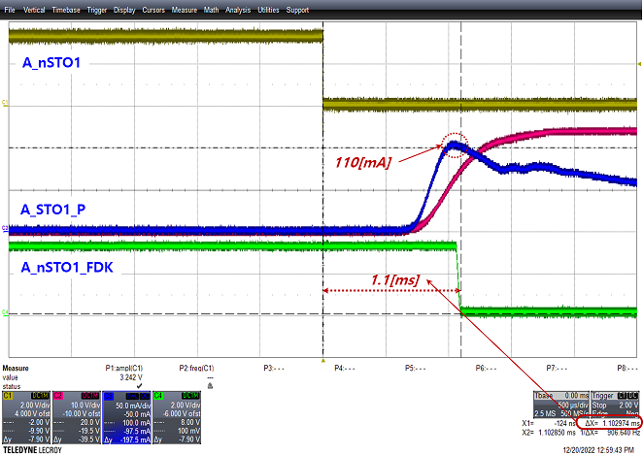 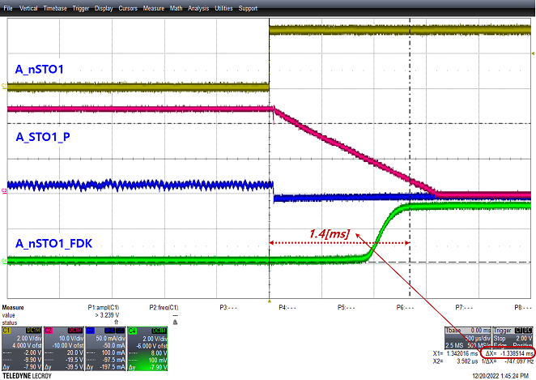

* + - Delay Time: 1.1[ms] (ON), 1.4[ms] (OFF)

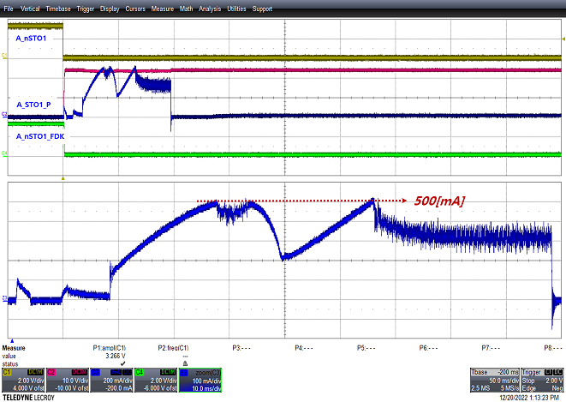 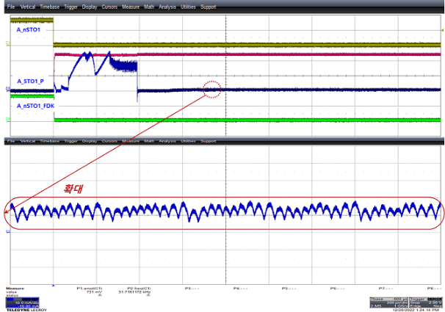

Coil of MC2 on/off Waveform (Ch.2)

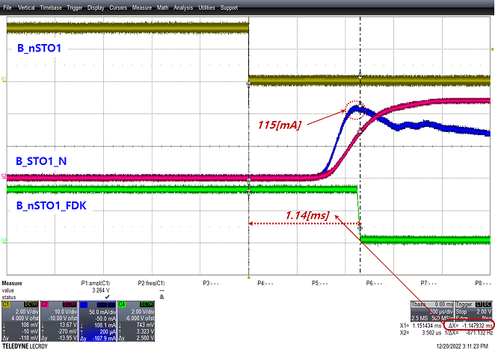 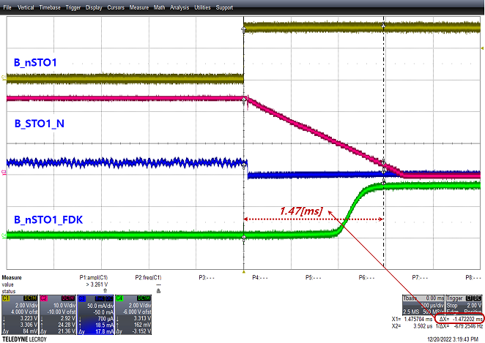

* + - Delay Time: 1.14[ms] (ON), 1.47[ms] (OFF)

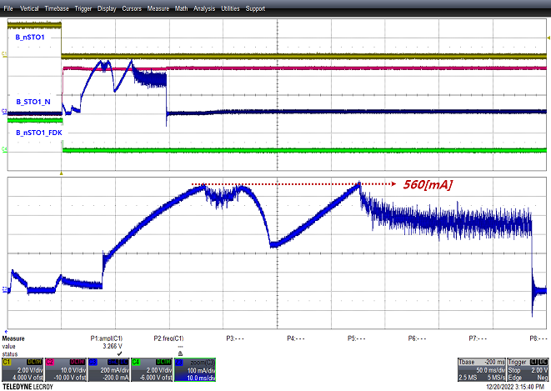 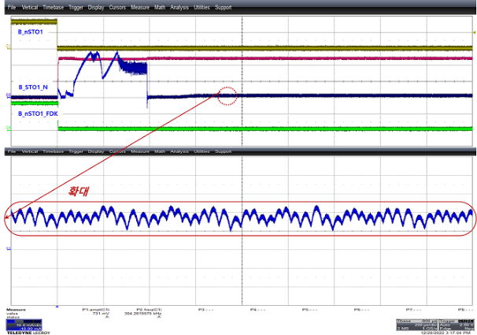

Auxiliary contact of MC1 on/off Waveform (Ch.1)

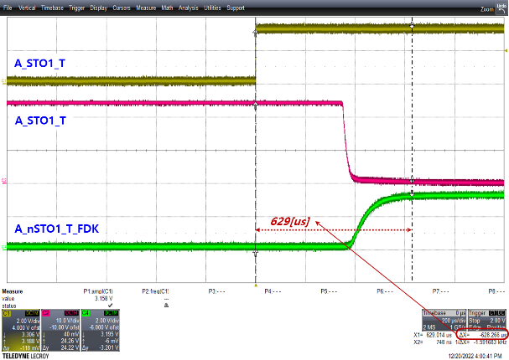 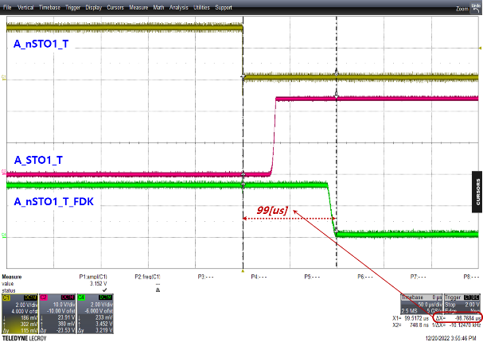

* + - Delay Time: 629[us] (ON), 99[us] (OFF)

Auxiliary contact of MC2 on/off Waveform (Ch.2)

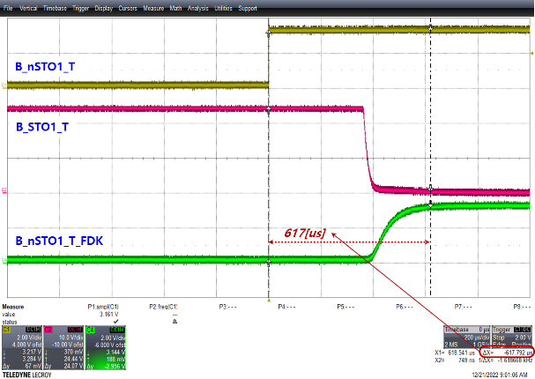 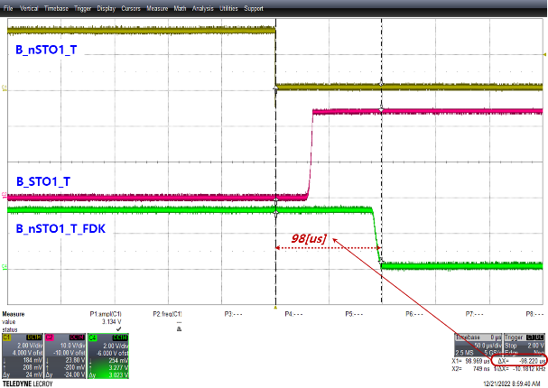

* + - Delay Time: 617[us] (ON), 98[us] (OFF)

#### Test result

| **Type** | **Name** | **Usage** | **Contents** | **Normal status** | **Measured**  **Value** | **Pass/Fail** | **Comments** |
| --- | --- | --- | --- | --- | --- | --- | --- |
| Ch.1 | A_nSTO1 | STO output1(Ch.1) | A_nSTO1=LOW | A_STO1_P = HIGH(: AS_P24V)  A_nSTO1_FDK = LOW  (: Feedback signal) | Refer to  Chapter  3.8.4.2.  Attached  Waveform | Pass |  |
| A_nSTO1=HIGH | A_STO1_P = LOW(: AS_G)  A_nSTO1_FDK = HIGH  (: Feedback signal) | Pass |  |
| A_nSTO1_T | Auxiliary contact of  STO output1(Ch.1) | Close(A_STO1_T &  A_STO1_T_FDK) | A_nSTO1_T =  A_nSTO1_T_FDK | Pass |  |
| Opne(A_STO1_T &  A_STO1_T_FDK) | A_nSTO1_T = HIGH | Pass |  |
| Ch.2 | B_nSTO1 | STO output1(Ch.2) | B_nSTO1=LOW | B_STO1_N = HIGH(: BS_G)  B_nSTO1_FDK = LOW  (: Feedback signal) | Pass |  |
| B_nSTO1=HIGH | B_STO1_P = LOW(: BS_P24V)  B_nSTO1_FDK = HIGH  (: Feedback signal) | Pass |  |
| B_nSTO1_T | Auxiliary contact of  STO output1(Ch.2) | Close(B_STO1_T &  B_STO1_T_FDK) | B_nSTO1_T =  B_nSTO1_T_FDK | Pass |  |
| Opne(B_STO1_T &  B_STO1_T_FDK) | B_nSTO1_T = HIGH | Pass |  |

## Temperature function(: HF109)

### Test purpose

Check the stability of temperature for reliable system. It is also intended to refer to firmware coding for applications software.

### Tools

For details on the tools used for this test, refer to Chapter 2. Used Tools.

* + - Oscilloscope
* Power Supply or SMPS
  + - JTAG Debugger
    - Code Composer Studio
    - RS232toUSB
    - PC
    - Monitoring and Control Interface
    - Temperature Meter

### Procedures

Proceed with the test according to the procedure below.

* + - Supply DC 24[V]±10% to safety controller with power supply or SMPS.
    - Download the program for the test using the JTAG Debugger & Code Composer Studio.
    - Measure and record the temperature sensor IC chip(U42,U43) using the temperature sensor, and then compare it with the temperature value calculated on the monitoring and control interface.

### Test result

#### Test condition

The test condition for the test is shown in the table below.

|  |  |  |  |  |
| --- | --- | --- | --- | --- |
| **Ch.** | **Schematics** | **Page** | **Measure**  **Position** | **Temperature around**  **measuring point** |
| Ch.1 |  | 20 page |  | - |
| Ch.2 | - |

#### Measure value

The calculated temperature values do not use a software filter at all, and the margin of error is ±10%.

|  |  |
| --- | --- |
| Measured by temperature sensor  Temperature value: 36.4[℃] | Ch.1 calculated temperature value(: x10 scale). |
| Ch.2 calculated temperature value(: x10 scale). |

#### Test result

|  |  |  |  |  |  |  |  |  |  |  |
| --- | --- | --- | --- | --- | --- | --- | --- | --- | --- | --- |
| **Channel** | **MCU port** | **Component** | **Notation** | **Posistion** | **Normal range[℃] /**  **Monitoring value[V]** | | | **Measured**  **Value** | **Pass/Fail** | **Comments** |
| **Min.** | **Nom.** | **Max.** |
| Ch.1 | ADCIN15 | U42 | B_TEMP | According to PCB  artwork design | 0.0 | 25.0 | 85.0 | 36.6 | Pass |  |
| 0.50 | 0.75 | 1.35 |  | Pass |  |
| Ch.2 | ADCIN15 | U43 | A_TEMP | According to PCB  artwork design | 0.0 | 25.0 | 85.0 | 36.5 | Pass |  |
| 0.50 | 0.75 | 1.35 |  | Pass |  |

## EMIF function(: HF110)

### Test purpose

Check the stability of emif function for reliable system. It is also intended to refer to firmware coding for applications software.

### Tools

For details on the tools used for this test, refer to Chapter 2. Used Tools.

* + - Oscilloscope
    - Power Supply or SMPS

### Procedures

Proceed with the test according to the procedure below.

* + - Supply DC 24[V]±10% to safety controller with power supply or SMPS.
    - Measure and record voltage, duty in each channel’s oscillator.
    - Download the program for the test using the JTAG Debugger & Code Composer Studio.
    - Measure and record the EMIF related pins(: CS, WE, OE & etc).

### Test result

#### Test condition

The test condition for the test is shown in the table below.

|  |  |  |  |  |  |
| --- | --- | --- | --- | --- | --- |
| **Ch.** | **Schematics** | **Page** | **Notation** | **Measure**  **Point** | **Temperature around**  **measuring point** |
|  |  | 7 page | M1_nCS2  M1_nCS3  M1_nWE  M1_nOE | RA10 / 4pin  RA10 / 3pin  RA10 / 2pin  RA10 / 1pin | 30.7[℃] |
| M1_A[0:12]  M1_D[0:15] | RA6~8  RA9~13 | 30.9[℃] |

The EMIF firmware was set as follows based on read and wirte in the picture below.

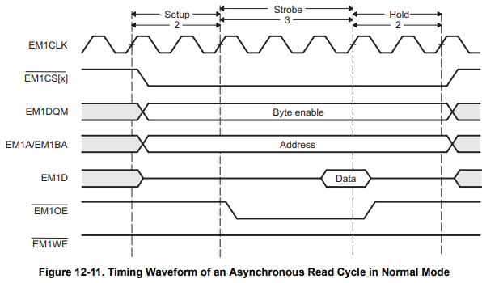 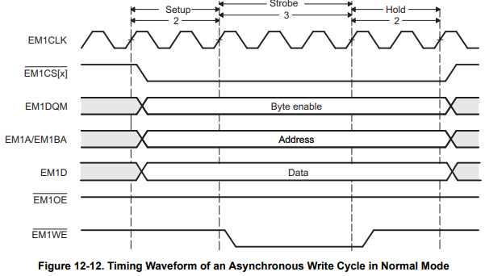

* + - EM1CLK: 10[ns]
    - Setup time: 1(: 10[ns])
    - Strobe time: 3(: 30[ns])
    - Hold time: 1(: 10[ns])

#### Measure value

Since simultaneous measurement is not possible(Resistor size 1005[mm]), measure and record one signal at a time.

An address bus and a data bus lines typically measure and record only one signal each.

|  |  |
| --- | --- |
| CS(chip select) Active low  Active time: about 50[ns] | OE(out enable) Active low  Active time: about 30[ns] |
| WE(write enable) Active low  Active time: about 30[ns] |

|  |  |
| --- | --- |
| Address 0 is data.  Active time: about 90[ns] | Address 0 is data.  Active time: about 90[ns] |

#### Test result

| **Type** | **Name** | **Usage** | **Contents** | **Normal status** | **Measured**  **Value** | **Pass/Fail** | **Comments** |
| --- | --- | --- | --- | --- | --- | --- | --- |
|  | Mx_nCSy | Chip Select | Mx_nCSy=LOW | Chip select Access state | Refer to  Chapter  3.10.4.1  and  3.10.4.2.  Attached  Waveform | Pass |  |
| Mx_nCSy=HIGH | Chip select no Access state | Pass |  |
| Mx_nWE | Write Enable | Mx_nWE=LOW | Write Enable Access state | Pass |  |
| Mx_nWE=HIGH | Write Enable no Access state | Pass |  |
| Mx_nOE | Read Enable | Mx_nOE=LOW | Read Enable Access state | Pass |  |
| Mx_nOE=HIGH | Read Enable no Access state | Pass |  |
| Mx_D0 ~ 15 | Data Bus | Mx_D0~15=LOW | Bit of Data Bus is ‘0‘ state | Pass |  |
| Mx_D0~15=HIGH | Bit of Data Bus is ‘1‘ state | Pass |  |
| Mx_BA1,  Mx_A0 ~ 12 | Address Bus | Mx_BA1, A0~12=LOW | Bit of Data Bus is ‘0‘ state | Pass |  |
| Mx_BA1, A0~12=HIGH | Bit of Data Bus is ‘1‘ state | Pass |  |

## Brake control function(:HF111)

### Test purpose

Check the stability of brake control function for reliable system. It is also intended to refer to firmware coding for applications software.

### Tools

For details on the tools used for this test, refer to Chapter 2. Used Tools.

* Oscilloscope
* Power Supply or SMPS
  + - JTAG Debugger
    - Code Composer Studio
    - RS232toUSB
    - PC
    - Monitoring and Control Interface

### Procedures

Proceed with the test according to the procedure below.

* + - Supply DC 24[V]±10% to safety controller with power supply or SMPS.
    - Download the program for the test using the JTAG Debugger & Code Composer Studio.
    - Use the RS232toUSB Converter & Monitoring and Control Interface to command the brake to be ON(:Relase).
    - Measure and record brake output and input (feedback) signals.
    - Use the RS232toUSB Converter & Monitoring and Control Interface to command the brake to be OFF(:Hold).
    - Measure and record brake output and input (feedback) signals.
    - Measure and crecord all brake 8EA in the above method.

### Test result

#### Test condition

The test condition for the test is shown in the table below.

|  |  |  |  |  |  |
| --- | --- | --- | --- | --- | --- |
| **Ch.** | **Schematics** | **Page** | **Notation** | **Measure**  **Point** | **Temperature around**  **measuring point** |
| Ch.1 |  | 23 page | BRK_nDO1 | PC21 / 2pin | 30.7[℃] |
| Ch.2 | BRK_nDI1 | PC23 / 10pin | 30.9[℃] |
| Ch.1 | - Omitted due to space.  - Similar to the picture above, only the part  number is different. | 23 page | BRK_Ndo2 | PC21 / 4pin | 30.7[℃] |
| Ch.2 | BRK_nDI2 | PC23 / 12pin | 30.9[℃] |
| Ch.1 | 23 page | BRK_nDO3 | PC21 / 6pin | 30.7[℃] |
| Ch.2 | BRK_nDI3 | PC23 / 14pin | 30.9[℃] |
| Ch.1 | 23 page | BRK_nDO4 | PC21 / 8pin | 30.7[℃] |
| Ch.2 | BRK_nDI4 | PC23 / 16pin | 30.9[℃] |
| Ch.1 | 23 page | BRK_nDO5 | PC22 / 2pin | 30.7[℃] |
| Ch.2 | BRK_nDI5 | PC24 / 10pin | 30.9[℃] |
| Ch.1 | 23 page | BRK_nDO6 | PC22 / 4pin | 30.7[℃] |
| Ch.2 | BRK_nDI6 | PC24 / 12pin | 30.9[℃] |
| Ch.1 | 23 page | BRK_nDO7 | PC22 / 6pin | 30.7[℃] |
| Ch.2 | BRK_nDI7 | PC24 / 14pin | 30.9[℃] |
| Ch.1 | 23 page | BRK_nDO8 | PC22 / 8pin | 30.7[℃] |
| Ch.2 | BRK_nDI8 | PC24 / 16pin | 30.9[℃] |

#### Measure value

* + - Test of Brake 1 Release/Hold

|  |  |
| --- | --- |
| Test of brake1 Release  - BRK_nDO1 is ‘L(:A_DG)’  - BRK_nDI1 is ‘L(:B_DG)’  Delay time: about 70[us] | Test of brake1 Hold  - BRK_nDO1 is ‘H(:AD_P3V3)’  - BRK_nDI1 is ‘H(:BD_P3V3)’  Delay time: about 5[ms] |

* + - Test of Brake 2 Release/Hold

|  |  |
| --- | --- |
| Test of brake2 Release | Test of brake2 Hold |

* + - Test of Brake 3 Release/Hold

|  |  |
| --- | --- |
| Test of brake3 Release | Test of brake3 Hold |

* + - Test of Brake 4 Release/Hold

|  |  |
| --- | --- |
| Test of brake4 Release | Test of brake4 Hold |

* + - Test of Brake 5 Release/Hold

|  |  |
| --- | --- |
| Test of brake5 Release | Test of brake5 Hold |

* + - Test of Brake 6 Release/Hold

|  |  |
| --- | --- |
| Test of brake6 Release | Test of brake6 Hold |

* + - Test of Brake 7 Release/Hold

|  |  |
| --- | --- |
| Test of brake7 Release | Test of brake7 Hold |

* + - Test of Brake 8 Release/Hold

|  |  |
| --- | --- |
| Test of brake8 Release | Test of brake8 Hold |

#### Test result

| **Type** | **Name** | **Usage** | **Contents** | **Normal status** | **Measured**  **Value** | **Pass/Fail** | **Comments** |
| --- | --- | --- | --- | --- | --- | --- | --- |
| Ch.1 | BRK_nDO1 | Brake1 output(Ch.1) | BRK_nDO1=LOW | Brake1 Release state  BRK1=BRK_P24V | Refer to  Chapter  3.11.4.2.  Attached  Waveform | Pass |  |
| BRK_nDO1=HIGH | Brake1 Hold state  BRK1=BRK_G | Pass |  |
| BRK_Ndo2 | Brake2 output(Ch.1) | BRK_nDO2=LOW | Brake2 Release state  BRK2=BRK_P24V | Pass |  |
| BRK_nDO2=HIGH | Brake2 Hold state  BRK2=BRK_G | Pass |  |
| BRK_nDO3 | Brake3 output(Ch.1) | BRK_nDO3=LOW | Brake3 Release state  BRK3=BRK_P24V | Pass |  |
| BRK_nDO3=HIGH | Brake3 Hold state  BRK3=BRK_G | Pass |  |
| BRK_nDO4 | Brake4 output(Ch.1) | BRK_nDO4=LOW | Brake4 Release state  BRK4=BRK_P24V | Pass |  |
| BRK_nDO4=HIGH | Brake4 Hold state  BRK4=BRK_G | Pass |  |
| BRK_nDO5 | Brake5 output(Ch.1) | BRK_nDO5=LOW | Brake5 Release state  BRK5=BRK_P24V | Pass |  |
| BRK_nDO5=HIGH | Brake5 Hold state  BRK5=BRK_G | Pass |  |
| BRK_nDO6 | Brake6 output(Ch.1) | BRK_nDO6=LOW | Brake6 Release state  BRK6=BRK_P24V | Pass |  |
| BRK_nDO6=HIGH | Brake6 Hold state  BRK6=BRK_G | Pass |  |
| BRK_nDO7 | Brake7 output(Ch.1) | BRK_nDO7=LOW | Brake7 Release state  BRK7=BRK_P24V | Pass |  |
| BRK_nDO7=HIGH | Brake7 Hold state  BRK7=BRK_G | Pass |  |
| BRK_nDO8 | Brake8 output(Ch.1) | BRK_nDO8=LOW | Brake8 Release state  BRK8=BRK_P24V | Pass |  |
| BRK_nDO8=HIGH | Brake8 Hold state  BRK8=BRK_G | Pass |  |
| Ch.2 | BRK_nDI1 | Brake1 output  monitoring (Ch.2) | Brake Relase state | BRK_nDI1=BRK_nDO1=LOW | Pass |  |
| Brake Hold state | BRK_nDI1=BRK_nDO1=HIGH | Pass |  |
| BRK_nDI2 | Brake2 output  monitoring (Ch.2) | Brake Relase state | BRK_nDI2=BRK_nDO2=LOW | Pass |  |
| Brake Hold state | BRK_nDI2=BRK_nDO2=HIGH | Pass |  |
| BRK_nDI3 | Brake3 output  monitoring (Ch.2) | Brake Relase state | BRK_nDI3=BRK_nDO3=LOW | Pass |  |
| Brake Hold state | BRK_nDI3=BRK_nDO3=HIGH | Pass |  |
| BRK_nDI4 | Brake4 output  monitoring (Ch.2) | Brake Relase state | BRK_nDI4=BRK_nDO4=LOW | Pass |  |
| Brake Hold state | BRK_nDI4=BRK_nDO4=HIGH | Pass |  |
| BRK_nDI5 | Brake5 output  monitoring (Ch.2) | Brake Relase state | BRK_nDI5=BRK_nDO5=LOW | Pass |  |
| Brake Hold state | BRK_nDI5=BRK_nDO5=HIGH | Pass |  |
| BRK_nDI6 | Brake6 output  monitoring (Ch.2) | Brake Relase state | BRK_nDI6=BRK_nDO6=LOW | Pass |  |
| Brake Hold state | BRK_nDI6=BRK_nDO6=HIGH | Pass |  |
| BRK_nDI7 | Brake7 output  monitoring (Ch.2) | Brake Relase state | BRK_nDI7=BRK_nDO7=LOW | Pass |  |
| Brake Hold state | BRK_nDI7=BRK_nDO7=HIGH | Pass |  |
| BRK_nDI8 | Brake8 output  monitoring (Ch.2) | Brake Relase state | BRK_nDI8=BRK_nDO8=LOW | Pass |  |
| Brake Hold state | BRK_nDI8=BRK_nDO8=HIGH | Pass |  |

#### Other confirmation test waveform

The waveforms below show the voltage and current waveforms applied to the actual brake during brake ON(release) / OFF(hold).

|  |  |
| --- | --- |
|  |  |

## EtherCAT function(:HF112) <- todo

### Test purpose

Check the stability of EtherCAT communication for reliable system. It is also intended to refer to firmware coding for applications software.

### Tools

For details on the tools used for this test, refer to Chapter 2. Used Tools.

* + - Oscilloscope
    - Ethernet compliance software
    - Compliance test board
    - Power Supply or SMPS

### Procedures

Proceed with the test according to the procedure below.

* + - Connect the oscilloscope and the compliance test board using a BNC cable.
    - Connect between the compliance test board and the DUT using an RJ45 cable.
    - Supply DC 24[V]±10% to safety controller with power supply or SMPS.
    - Measure and record while performing test items using Ethernet compliance software.
    - Perform the above measurement and recording of A-pair and B-pair of input/output ports respectively.

### Test result

#### Test condition

The test condition for the test is shown in the table below.

|  |  |  |  |  |  |
| --- | --- | --- | --- | --- | --- |
| **Ch.** | **Schematics** | **Page** | **Notation** | **Measure**  **Point** | **Temperature around**  **measuring point** |
|  |  | 9 page | Z_TXP0  Z_TXM0  Z_RXP0  Z_RXM0 | J5 / 1pin  J5 / 2pin  J5 / 3pin  J5 / 6pin | 27.7[℃] |
|  | 8 page | Z_TXP1  Z_TXM1  Z_RXP1  Z_RXM1 | J4 / 1pin  J4 / 2pin  J4 / 3pin  J4 / 6pin | 27.9[℃] |

#### Measure value

* + - Input Port A-Pair(J4, 1-2pins)
    - Input Port B-Pair(J4, 3-6pins)
    - Output Port A-Pair(J5, 1-2pins)

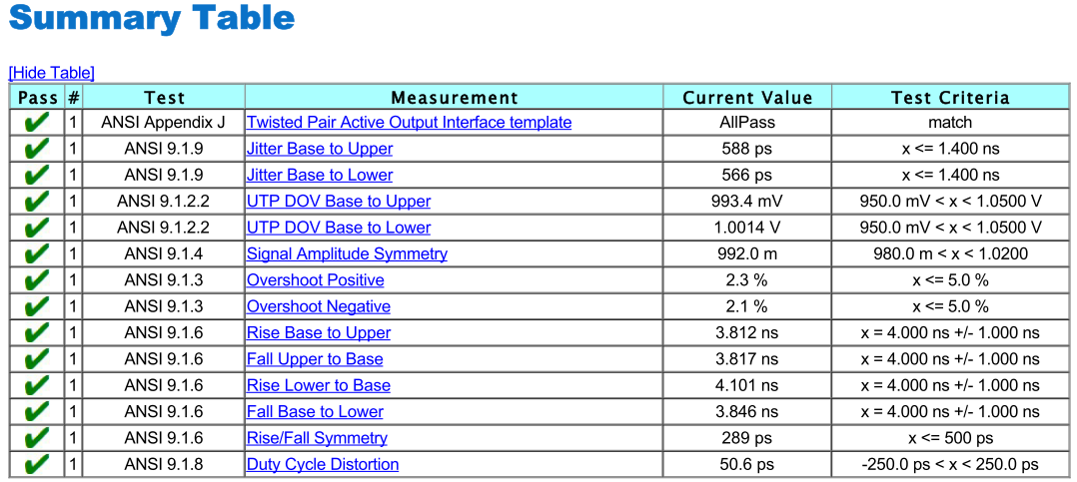

* + - Output Port B-Pair(J5, 3-6pins)

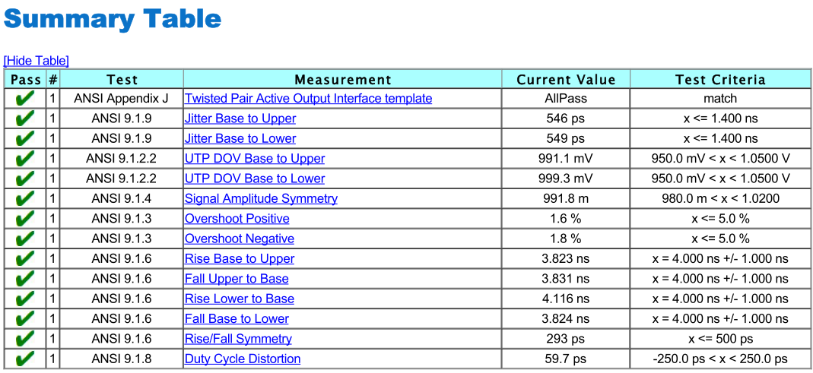

#### Test result

The test result is replaced by compliance test reports(Appendix A~D).

* + - [Appendix A]Compliance Test : Input Port A-Pair(J4, 1-2pins)
    - [Appendix B]Compliance Test : Input Port B-Pair(J4, 3-6pins)
    - [Appendix C]Compliance Test : Output Port A-Pair(J5, 1-2pins)
    - [Appendix D]Compliance Test : Output Port B-Pair(J5, 3-6pins)

## AMP board interface function(:HF113)

### Test purpose

Check the stability of AMP board inteface for reliable system. It is also intended to refer to firmware coding for applications software.

* + - Check the dead time of the PWM gating signal.
    - Check the delay time of the IPM failure signal.

### Tools

For details on the tools used for this test, refer to Chapter 2. Used Tools.

* + - Oscilloscope
    - Power Supply or SMPS
    - Test zig Board

### Procedures

Proceed with the test according to the procedure below.

* + - Supply DC 24[V]±10% to safety controller with power supply or SMPS.
    - Download the program for the test using the JTAG Debugger & Code Composer Studio.
    - Turn ON/OFF the signal correspoding to the system input/output function using the RS232toUSB Converter & Monitoring and Control Interface.
    - Measure and record the voltage corresponding to each signals (PWM gating signals, IPM fault signals).

### Test result

#### Test condition

The test condition for the test is shown in the table below.

* + PWM gating Signals

|  |  |  |  |  |  |
| --- | --- | --- | --- | --- | --- |
| **Ch.** | **Schematics** | **Page** | **Notation** | **Measure**  **Point** | **Temperature around**  **measuring point** |
| ZYNQ |  | 21 page | EX_nPWM_UP1  EX_nPWM_UN1  EX_nPWM_VP1  EX_nPWM_VN1  EX_nPWM_WP1  EX_nPWM_WN1 | UP1  UN1  VP1  VN1  WP1  WN1 | [℃] |
| - Omitted due to space.  - Similar to the picture above, only the part  number is different. | EX_nPWM_UP2  EX_nPWM_UN2  EX_nPWM_VP2  EX_nPWM_VN2  EX_nPWM_WP2  EX_nPWM_WN2 | UP2  UN2  VP2  VN2  WP2  WN2 | [℃] |
| EX_nPWM_UP3  EX_nPWM_UN3  EX_nPWM_VP3  EX_nPWM_VN3  EX_nPWM_WP3  EX_nPWM_WN3 | UP3  UN3  VP3  VN3  WP3  WN3 | [℃] |
| EX_nPWM_UP4  EX_nPWM_UN4  EX_nPWM_VP4  EX_nPWM_VN4  EX_nPWM_WP4  EX_nPWM_WN4 | UP4  UN4  VP4  VN4  WP4  WN4 | [℃] |
| EX_nPWM_UP5  EX_nPWM_UN5  EX_nPWM_VP5  EX_nPWM_VN5  EX_nPWM_WP5  EX_nPWM_WN5 | UP5  UN5  VP5  VN5  WP5  WN5 | [℃] |
| EX_nPWM_UP6  EX_nPWM_UN6  EX_nPWM_VP6  EX_nPWM_VN6  EX_nPWM_WP6  EX_nPWM_WN6 | UP6  UN6  VP6  VN6  WP6  WN6 | [℃] |
| EX_nPWM_UP7  EX_nPWM_UN7  EX_nPWM_VP7  EX_nPWM_VN7  EX_nPWM_WP7  EX_nPWM_WN7 | UP7  UN7  VP7  VN7  WP7  WN7 | [℃] |
| EX_nPWM_UP8  EX_nPWM_UN8  EX_nPWM_VP8  EX_nPWM_VN8  EX_nPWM_WP8  EX_nPWM_WN8 | UP8  UN8  VP8  VN8  WP8  WN8 | [℃] |

*Measure point is test zig board.

* + IPM Fault Signals

|  |  |  |  |  |  |
| --- | --- | --- | --- | --- | --- |
| **Ch.** | **Schematics** | **Page** | **Notation** | **Measure**  **Point** | **Temperature around**  **measuring point** |
| ZYNQ |  | 24 page | EX_IPM_nFLT1  IPM_nFLT1 | R899 / 1pin  PC26 / 16pin | [℃] |
| EX_IPM_nFLT2  IPM_nFLT2 | R903 / 1pin  PC26 / 14pin | [℃] |
| EX_IPM_nFLT3  IPM_nFLT3 | R908 / 1pin  PC26 / 12pin | [℃] |
| EX_IPM_nFLT4  IPM_nFLT4 | R912 / 1pin  PC26 / 10pin | [℃] |
|  | EX_IPM_nFLT5  IPM_nFLT5 | R938 / 1pin  PC31 / 16pin | [℃] |
| EX_IPM_nFLT6  IPM_nFLT6 | R947 / 1pin  PC31 / 14pin | [℃] |
| EX_IPM_nFLT7  IPM_nFLT7 | R950 / 1pin  PC31 / 12pin | [℃] |
| EX_IPM_nFLT8  IPM_nFLT8 | R952 / 1pin  PC31 / 10pin | [℃] |

#### Measure value

* + PWM gating Signals

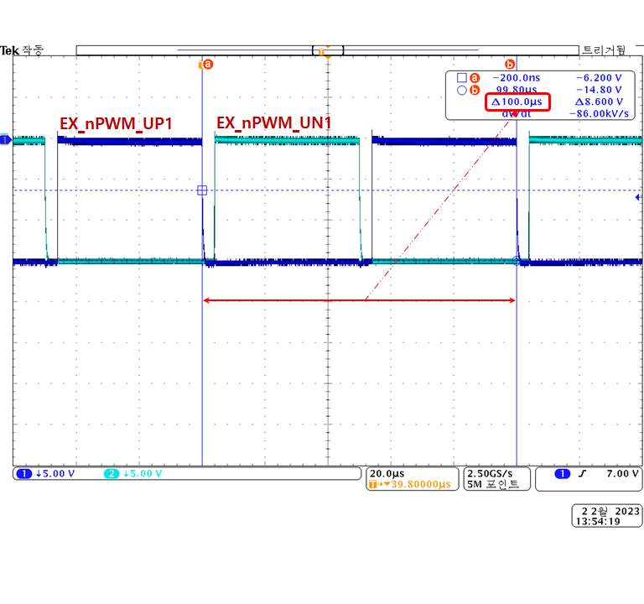 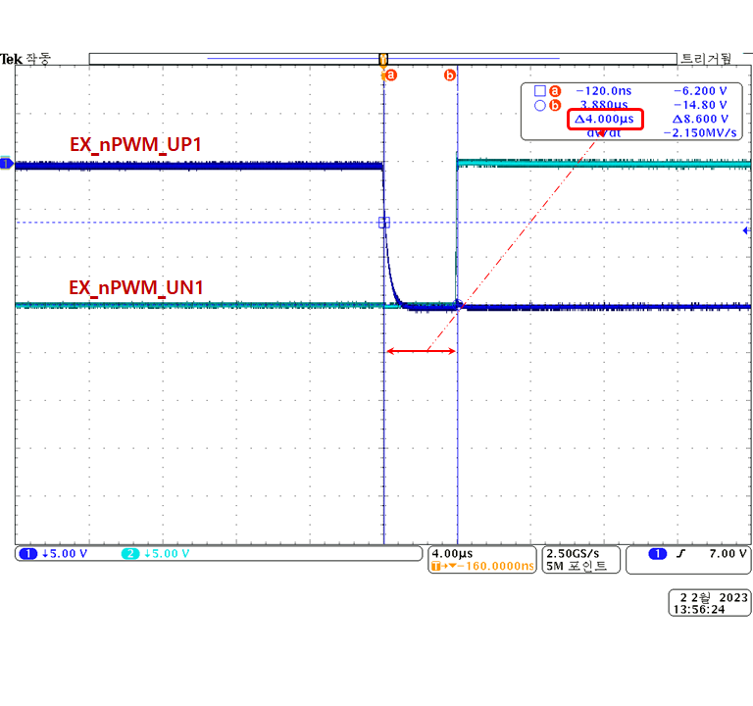

PWM waveform

* + - Duty Cycle: 50.0%
    - Carrier Frequency: 100[us](almost 10.0kHz)
    - Dead Time: 4.0[us]

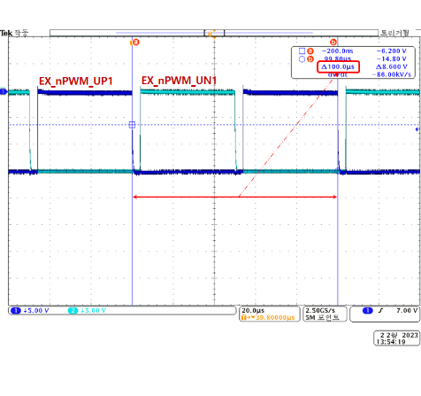 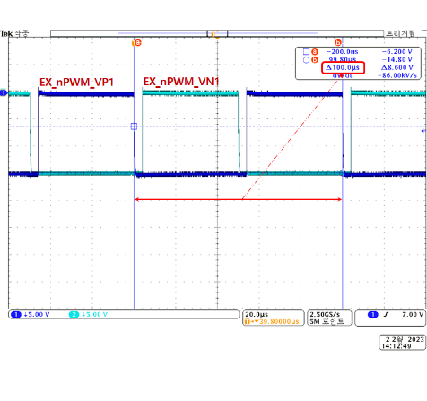 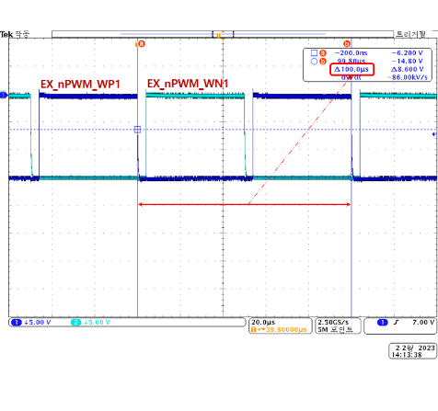

Axis 1

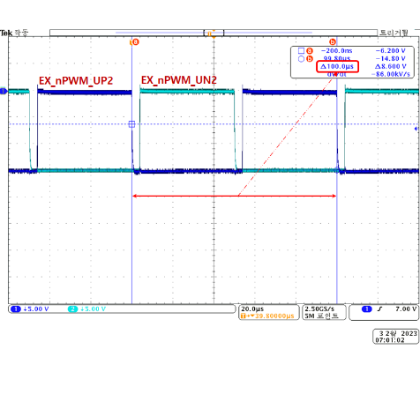 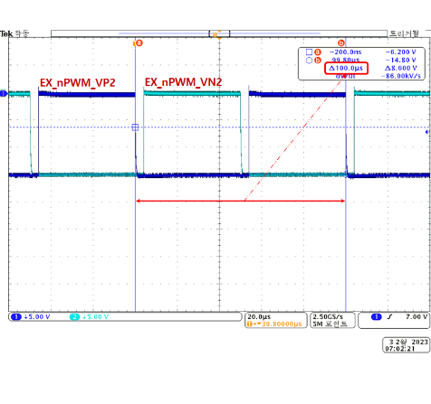 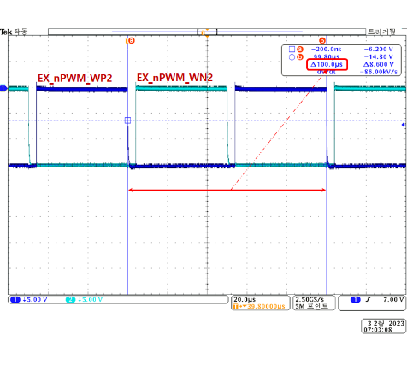

Axis 2

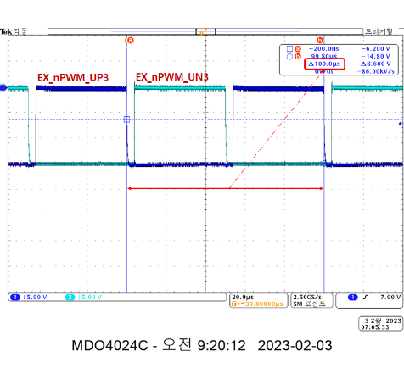 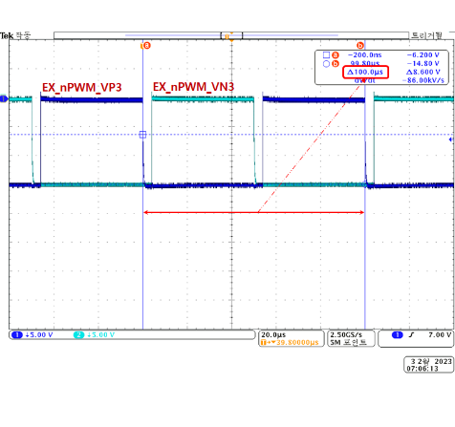 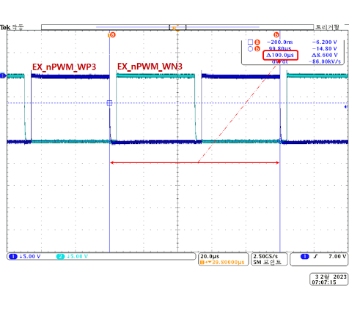

Axis 3

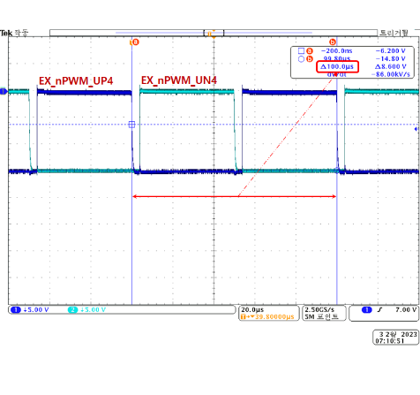 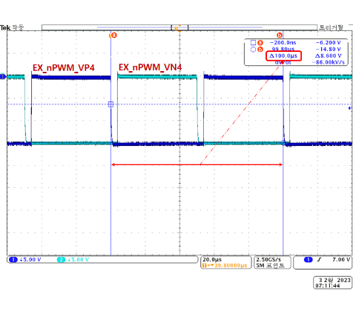 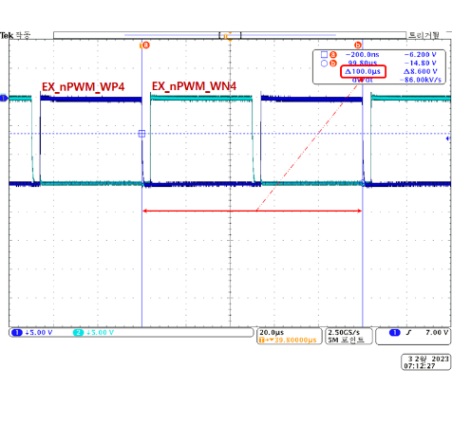

Axis 4

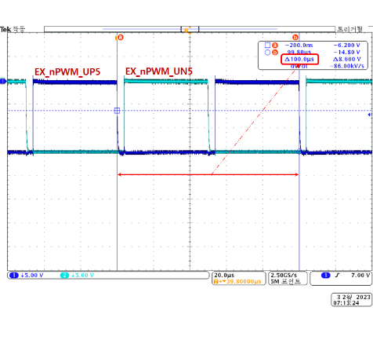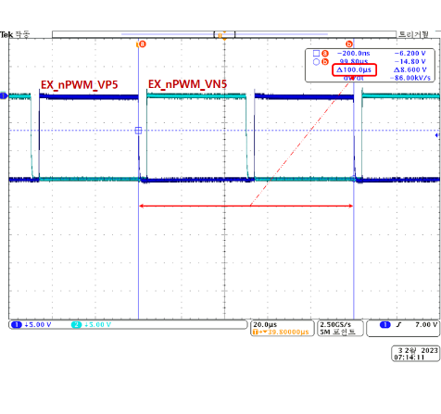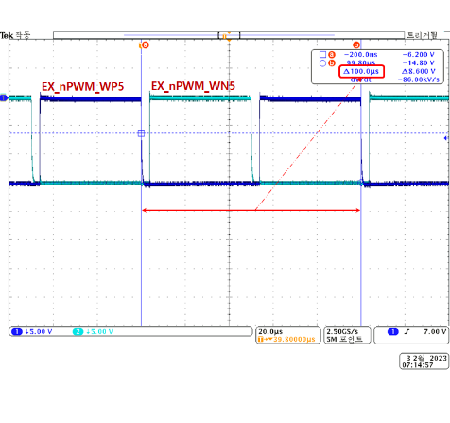

Axis 5

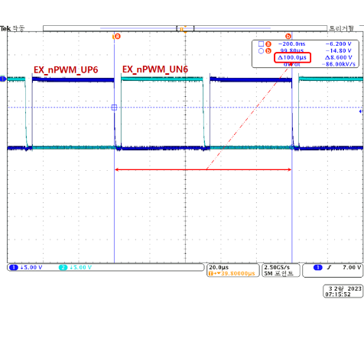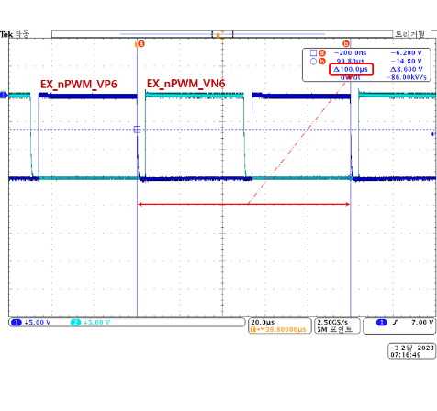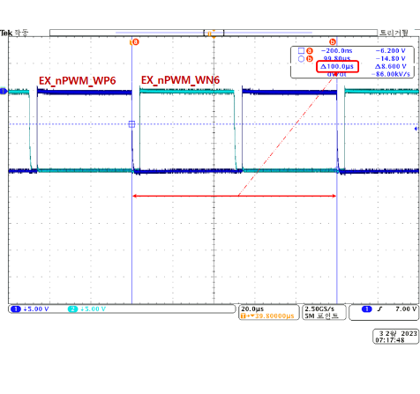

Axis 6

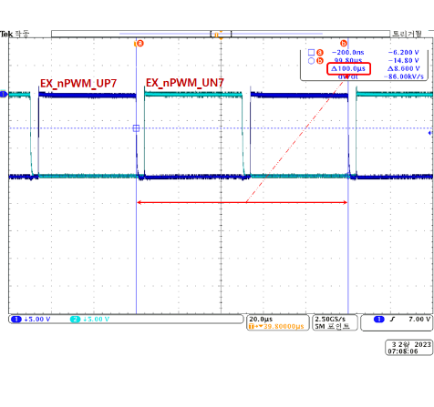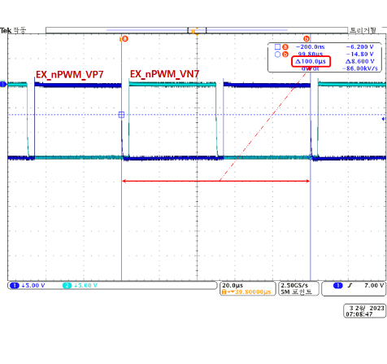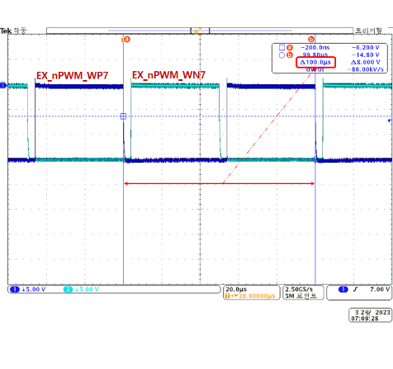

Axis 7

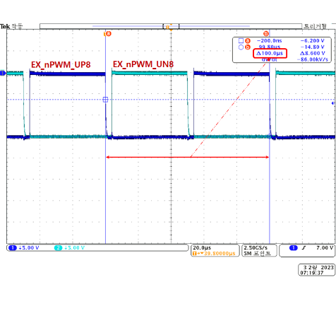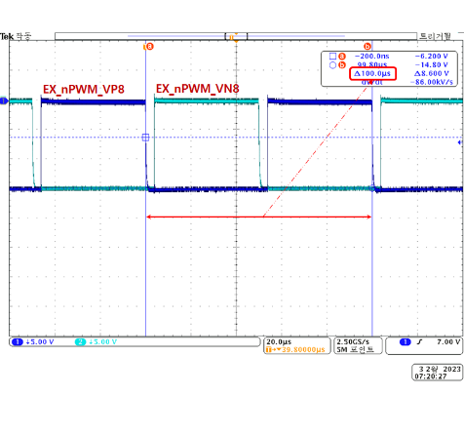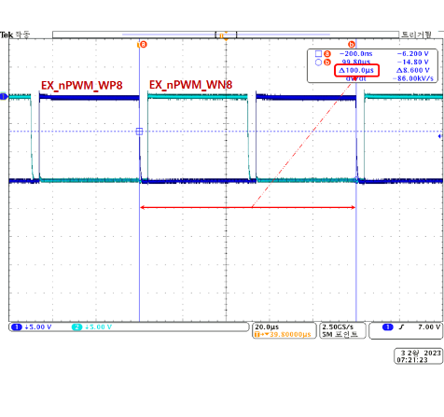

Axis 8

* + IPM Fault Signals

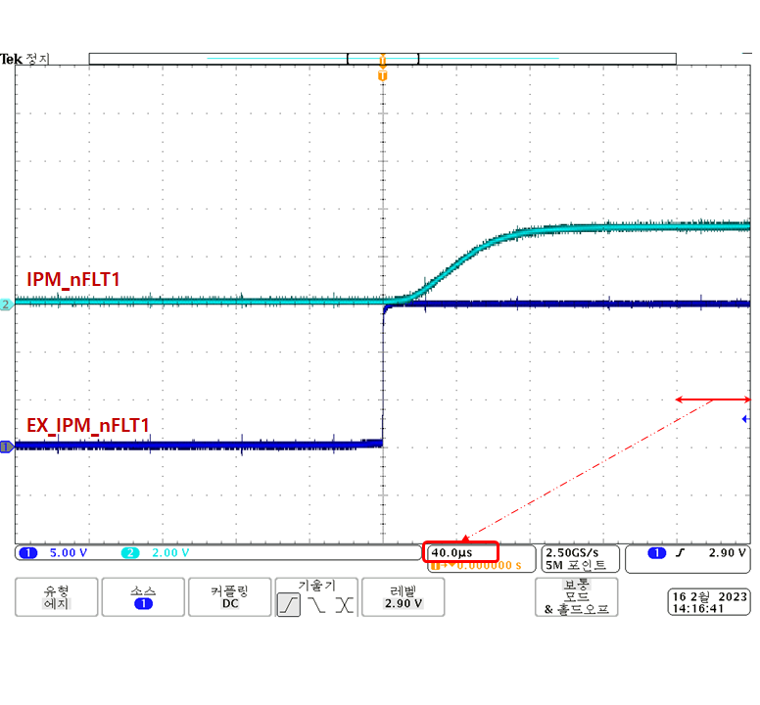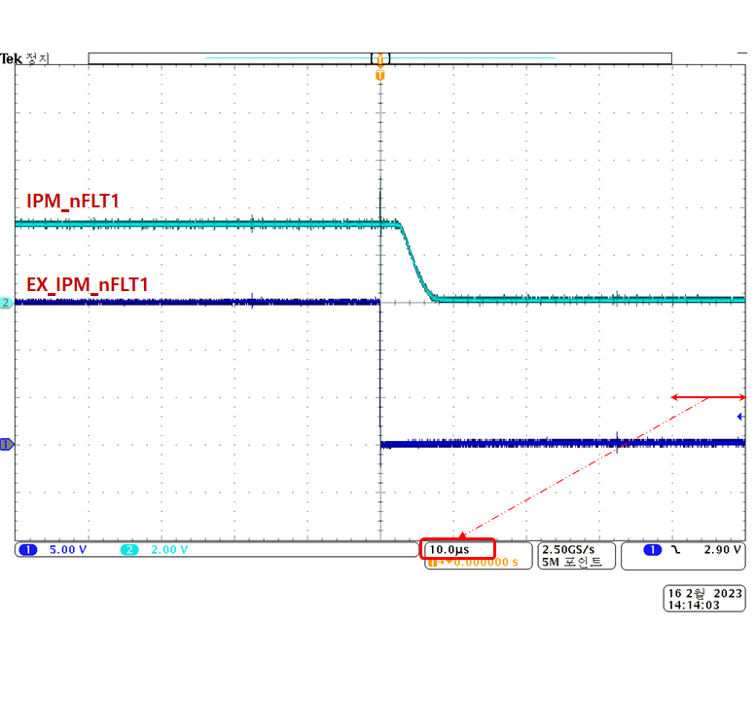

IPM Fault 1

IPM Fault waveform

* + - Turn ON Delay Time: 60.0[us] (80%)
    - Turn OFF Delay Time: 6.0[us] (20%)

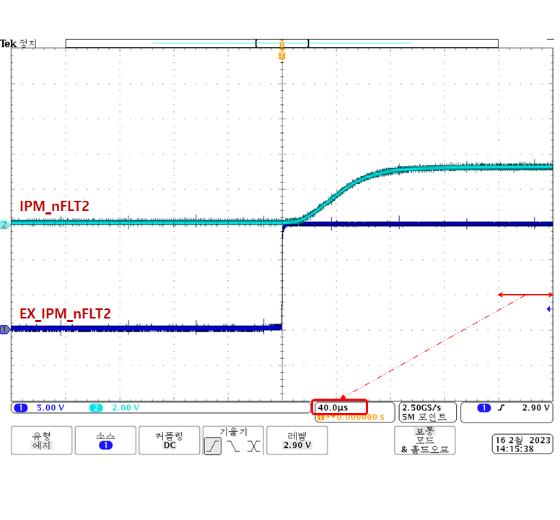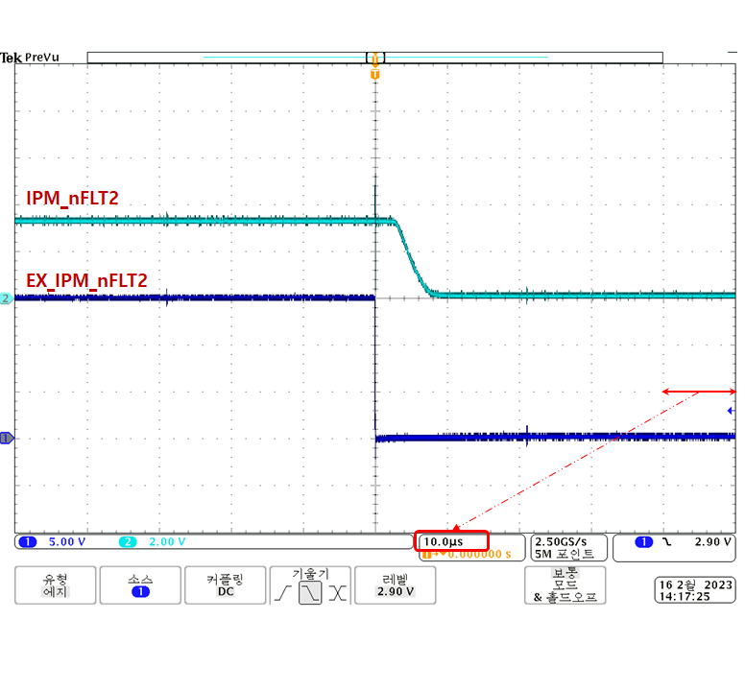

IPM Fault 2

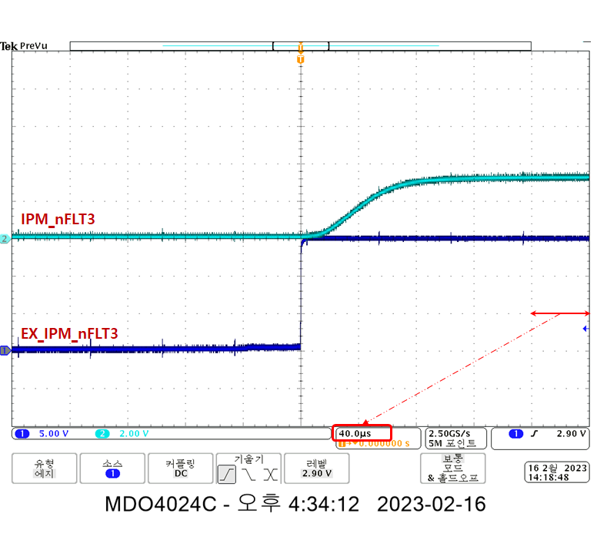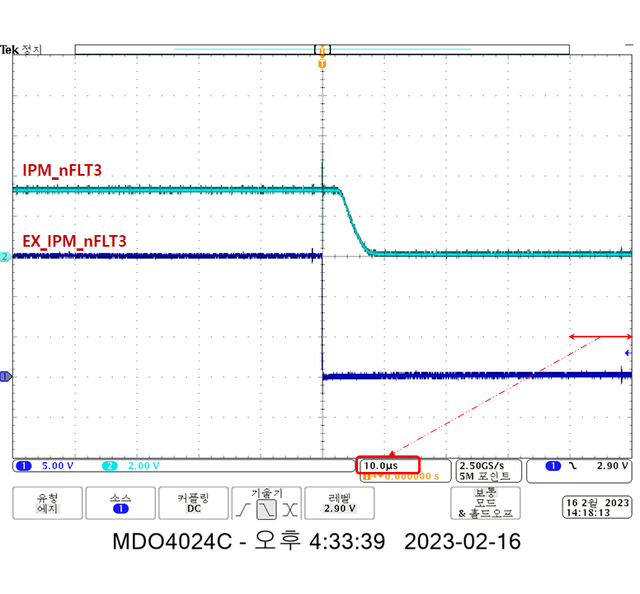

IPM Fault 3

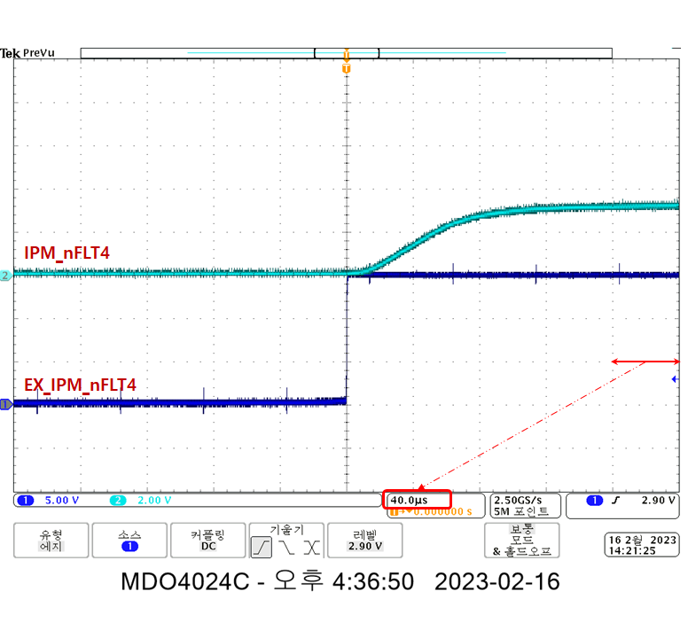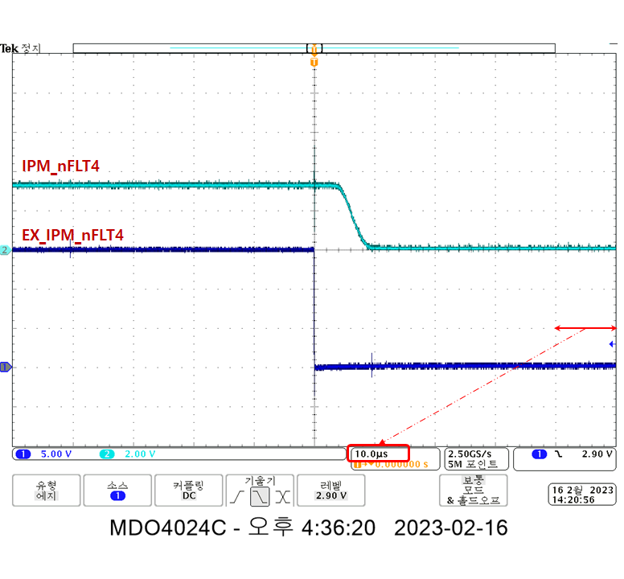

IPM Fault 4

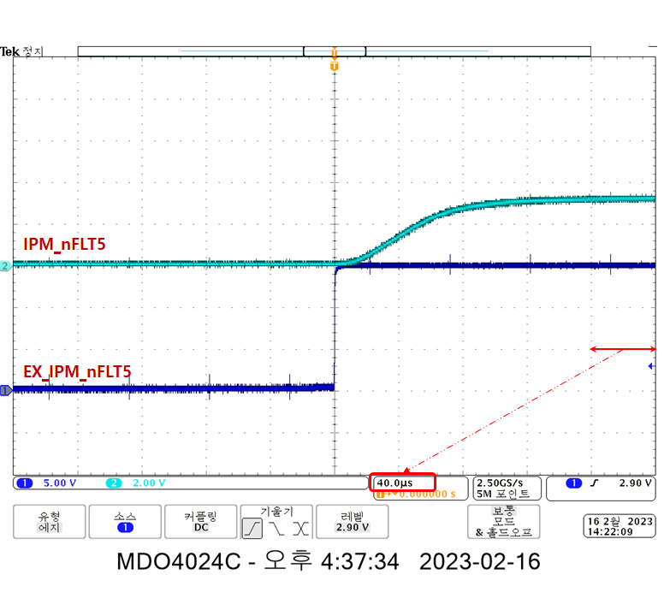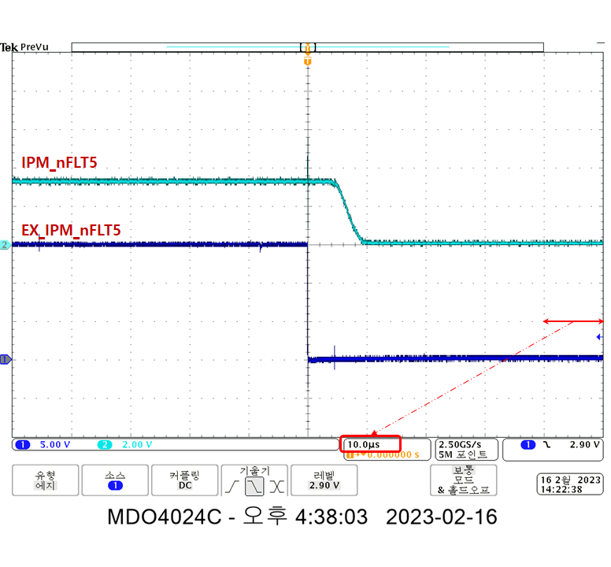

IPM Fault 5

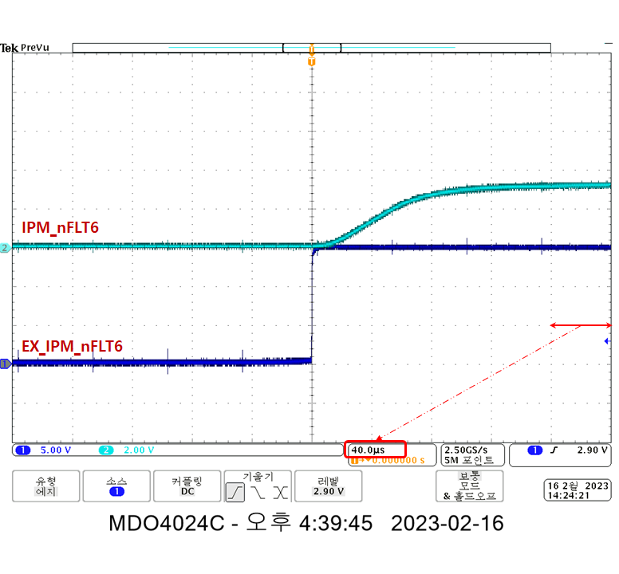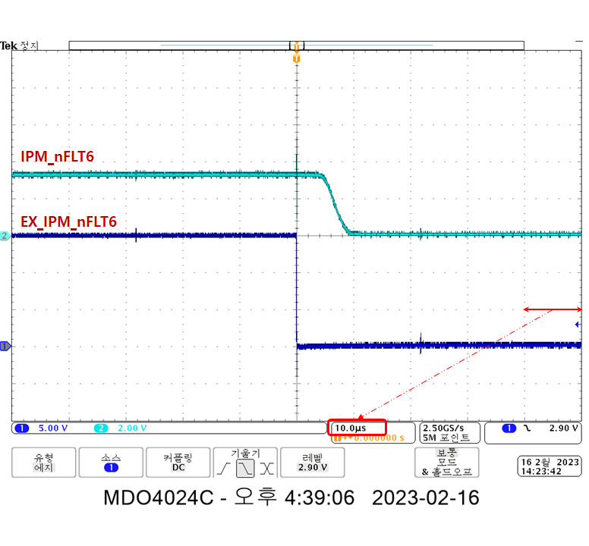

IPM Fault 6

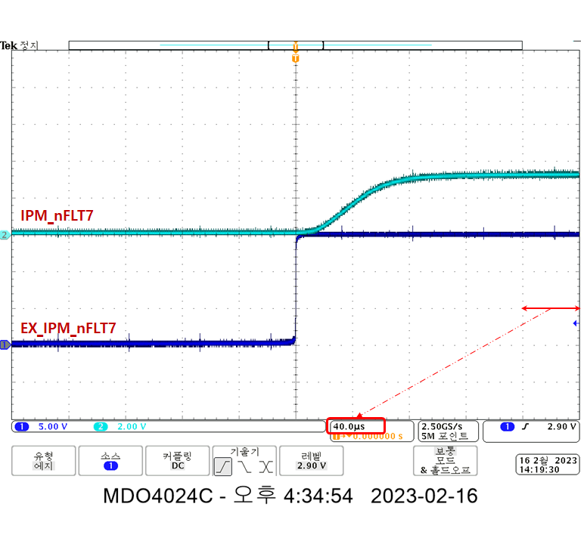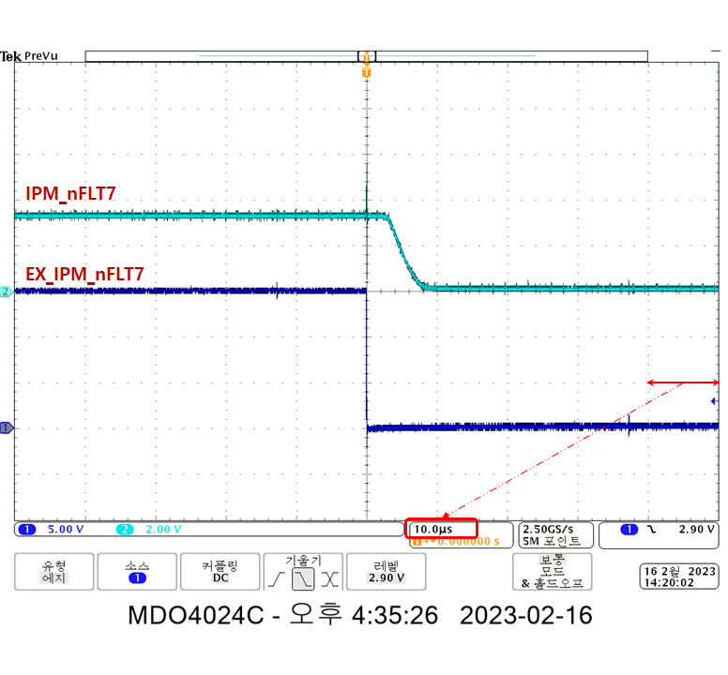

IPM Fault 7

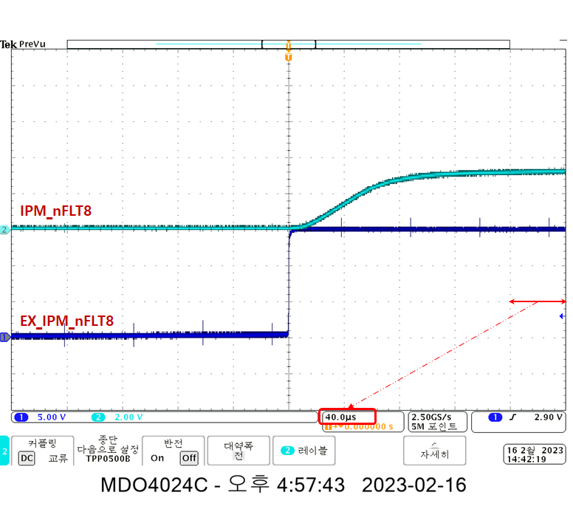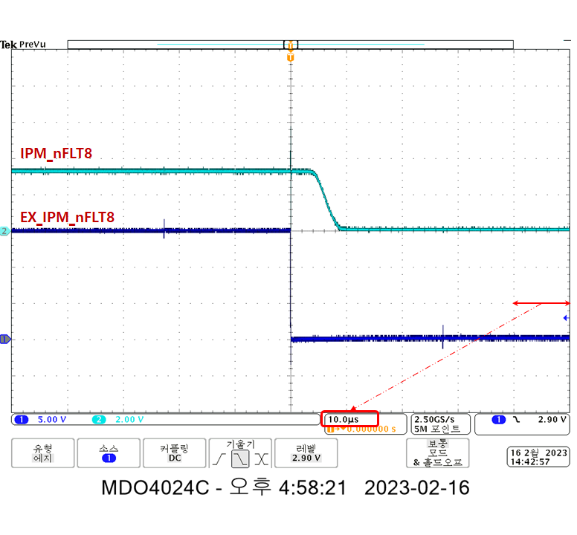

IPM Fault 8

#### Test result

| **Type** | **Name** | **Usage** | **Contents** | **Normal status** | **Measured**  **Value** | **Pass/Fail** | **Comments** |
| --- | --- | --- | --- | --- | --- | --- | --- |
|  | EX_SERVO_ONx | Servo ON/OFF  signal | SERVO_ONx=LOW | Servo ON state  EX_SERVO_ONx=P15V | Refer to  Chapter  3.13.4.2.  Attached  Waveform | Pass |  |
| SERVO_ONx=HIGH | Servo OFF state  EX_SERVO_ONx=EX_15G | Pass |  |
| EX_nPWM_UPx | PWM U-phase  Up side | PWM_UPx=LOW | PWM UPx Gating OFF state  EX_nPWM_UPx=P15V | Pass |  |
| PWM_UPx=HIGH | PWM UPx Gating ON state  EX_nPWM_UPx=EX_15G | Pass |  |
| EX_nPWM_UNx | PWM U-phase  Down side | PWM_UNx=LOW | PWM UNx Gating OFF state  EX_nPWM_UNx=P15V | Pass |  |
| PWM_UNx=HIGH | PWM UNx Gating ON state  EX_nPWM_UNx=EX_15G | Pass |  |
| EX_nPWM_VPx | PWM V-phase  Up side | PWM_VPx=LOW | PWM VPx Gating OFF state  EX_nPWM_VPx=P15V | Pass |  |
| PWM_VPx=HIGH | PWM VPx Gating ON state  EX_nPWM_VPx=EX_15G | Pass |  |
| EX_nPWM_VNx | PWM V-phase  Down side | PWM_VNx=LOW | PWM VNx Gating OFF state  EX_nPWM_VNx=P15V | Pass |  |
| PWM_VNx=HIGH | PWM VNx Gating ON state  EX_nPWM_VNx=EX_15G | Pass |  |
| EX_nPWM_WPx | PWM W-phase  Up side | PWM_WPx=LOW | PWM WPx Gating OFF state  EX_nPWM_WPx=P15V | Pass |  |
| PWM_WPx=HIGH | PWM WPx Gating ON state  EX_nPWM_WPx=EX_15G | Pass |  |
| EX_nPWM_WNx | PWM W-phase  Down side | PWM_WNx=LOW | PWM WNx Gating OFF state  EX_nPWM_WNx=P15V | Pass |  |
| PWM_WNx=HIGH | PWM WNx Gating ON state  EX_nPWM_WNx=EX_15G | Pass |  |
| EX_IPM_nFLTx | IPM fault  signal | EX_IPM_nFLTx=EX_15G | IPM Fault state  IPM_nFLTx=LOW | Pass |  |
| EX_IPM_nFLTx=P15V0 | IPM Normal state  IPM_nFLTx=HIGH | Pass |  |
| EX_IUNx | U-phase  current | These signals are covered in section 6.1.5. | | | | |
| EX_IVNx | V-phase  current |
| EX_IWNx | W-phase  current |

#### Other confirmation test waveform

The actual IPM fault signal is input as an active low pulse waveform. The pulse width is different depending on the type of IPM, but it is approximately 20usec at the minimum and 100usec at the maximum.

The waveform below shows the input waveform at the lowest pulse width of 20usec.

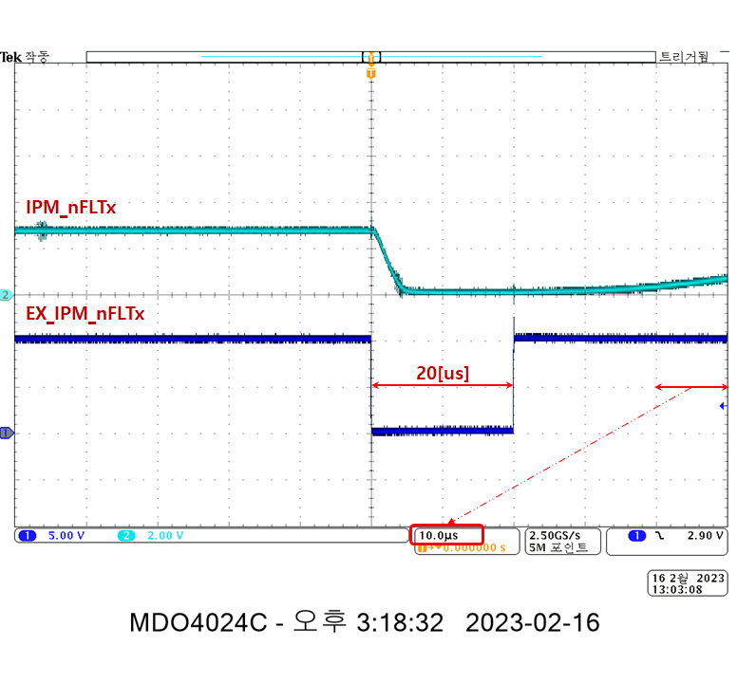

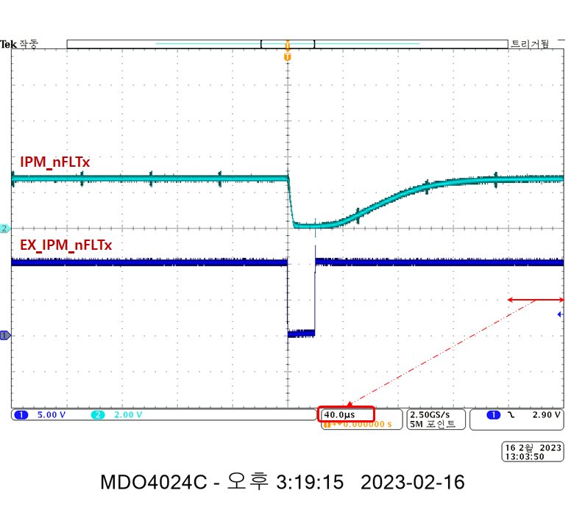

## Power control board interface function(: HF114)

### Test purpose

Check the stability of Power control board inteface for reliable system. It is also intended to refer to firmware coding for applications software.

* + - Check the delay time of the interface signals.

### Tools

For details on the tools used for this test, refer to Chapter 2. Used Tools.

* + - Oscilloscope
    - Power Supply or SMPS
    - JTAG Debugger
    - Code Composer Studio
    - RS232toUSB
    - PC

### Procedures

Proceed with the test according to the procedure below.

* + - Supply DC 24[V]±10% to safety controller with power supply or SMPS.
    - Download the program for the test using the JTAG Debugger & Code Composer Studio.
    - Turn ON/OFF the signal correspoding to the system input/output function using the RS232toUSB Converter & Monitoring and Control Interface.
    - Measure and record the voltage corresponding to each signals (MCON, RYON, DROH, DMOH, PNOV and PNUV signals).

### Test result

#### Test condition

The test condition for the test is shown in the table below.

|  |  |  |  |  |  |
| --- | --- | --- | --- | --- | --- |
| **Ch.** | **Schematics** | **Page** | **Notation** | **Measure**  **Point** | **Temperature around**  **measuring point** |
| ZYNQ |  | 24 page | EX_PNOV  Z_PNOV | R915 / 1pin  PC29 / 16pin | [℃] |
| EX_DROH  Z_DROH | R929 / 1pin  PC29 / 14pin | [℃] |
| EX_DMOH  Z_DMOH | R932 / 1pin  PC29 / 12pin | [℃] |
| EX_PNUV  Z_PNUV | R936 / 1pin  PC29 / 10pin | [℃] |
|  | EX_nMCON |  |  |
|  | EX_nMCON_FDK |  |  |
|  | EX_nRYON |  |  |
|  | EX_nRYON_FDK |  |  |

#### Measure value

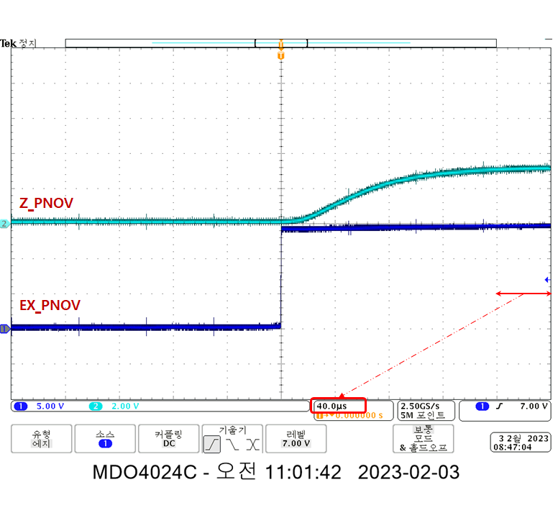 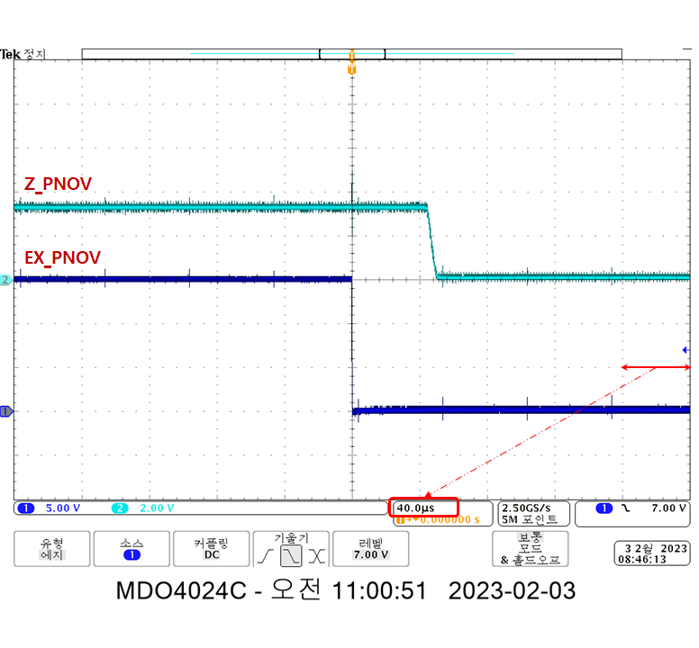

PNOV waveform

* + - Turn ON Delay Time: 60.0[us] (80%)
    - Turn OFF Delay Time: 48.0[us] (20%)

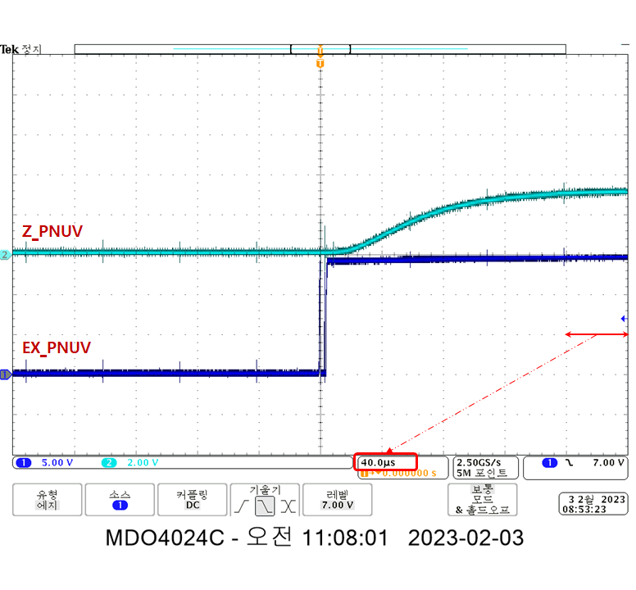 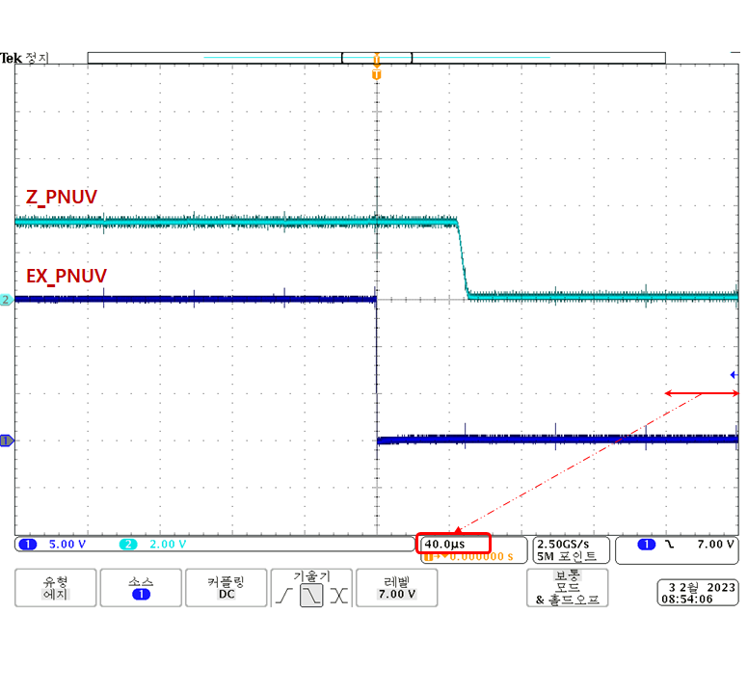

PNUV waveform

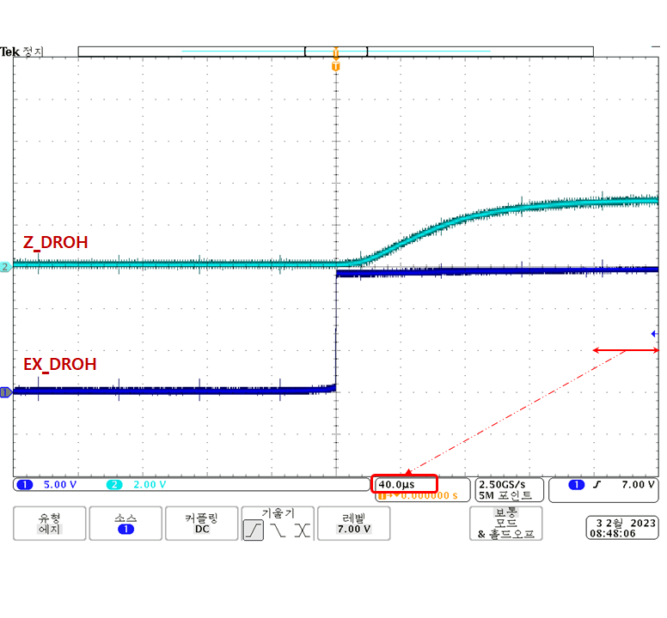 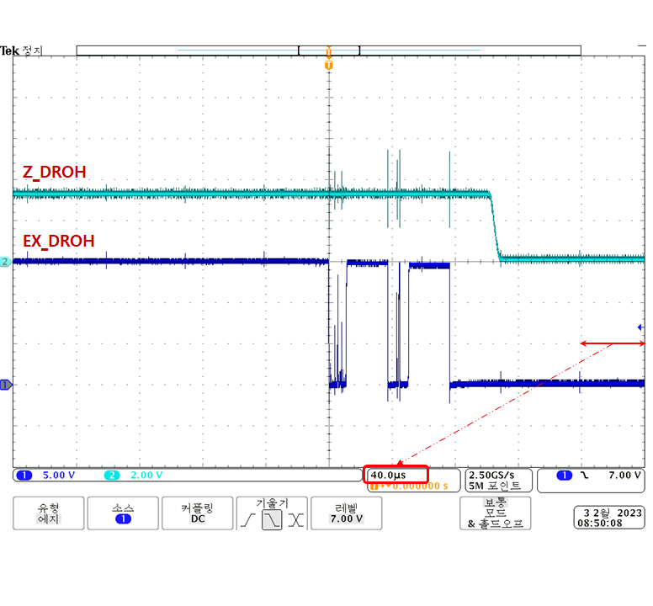

DROH waveform

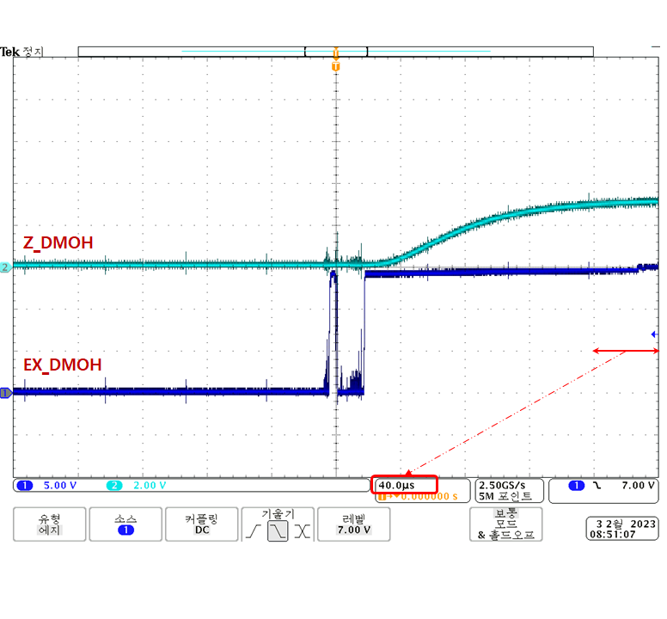 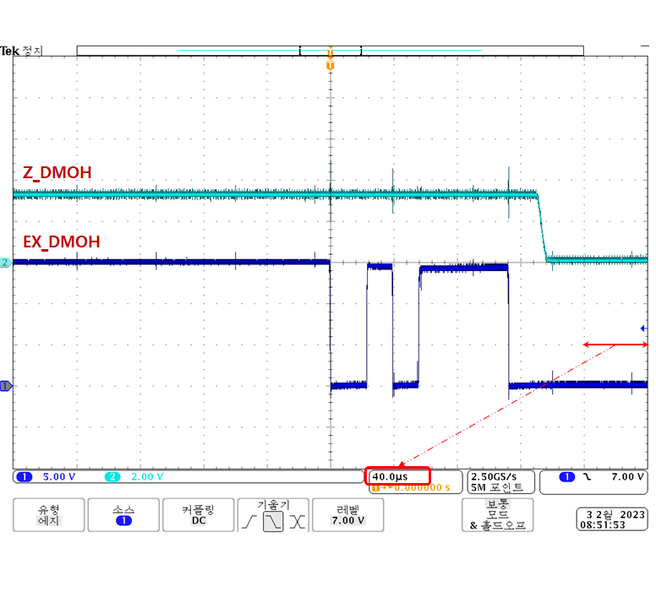

DMOH waveform

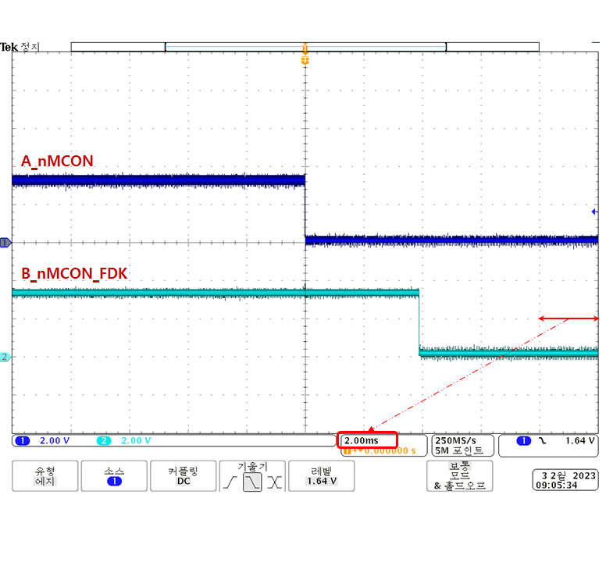 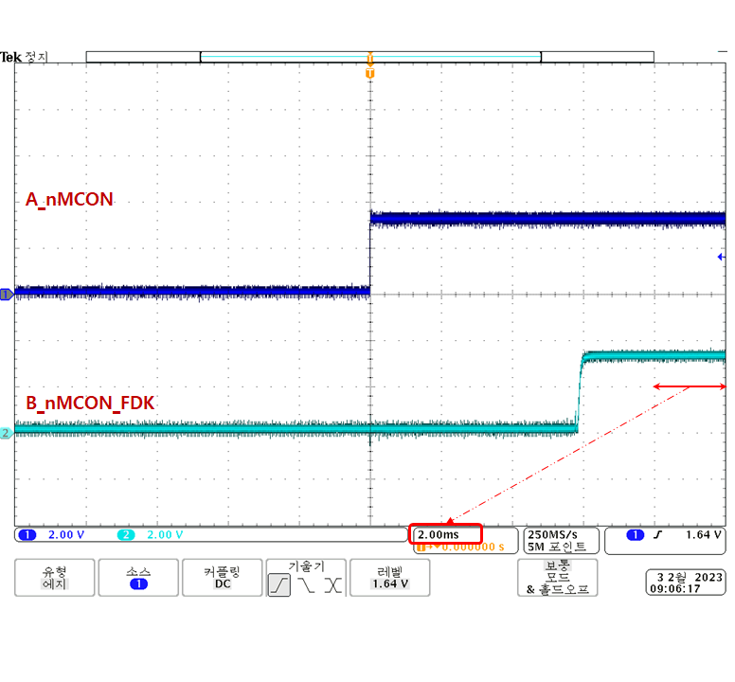

The feedback delay time of the test waveform is due to the circuit configuration of the test JIG board, the actual delay time is different.

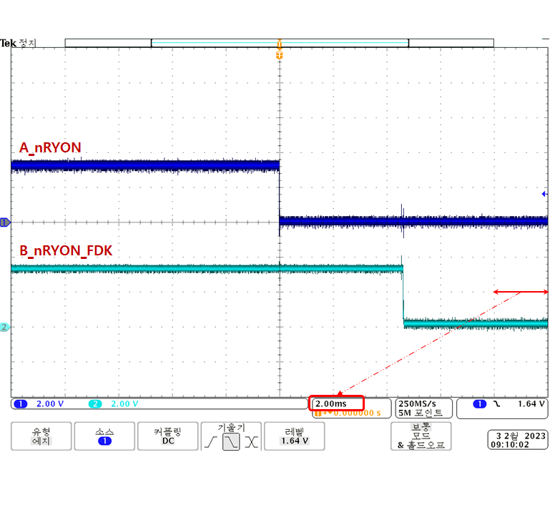 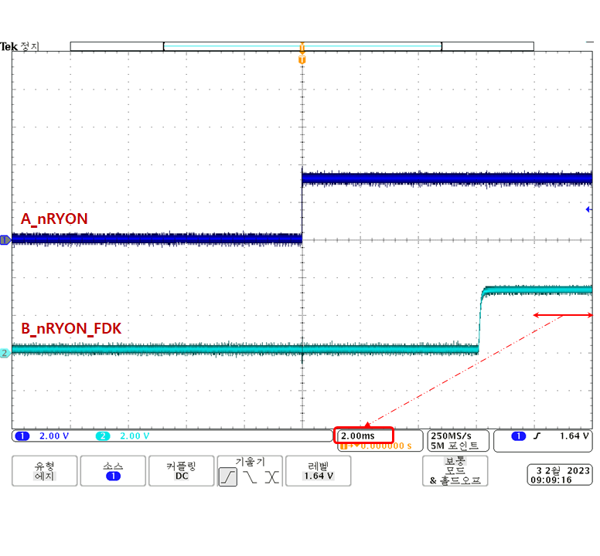

The feedback delay time of the test waveform is due to the circuit configuration of the test JIG board, the actual delay time is different.

#### Test result

| **Type** | **Name** | **Usage** | **Contents** | **Normal status** | **Measured**  **Value** | **Pass/Fail** | **Comments** |
| --- | --- | --- | --- | --- | --- | --- | --- |
|  | EX_PNOV | DC-Link  Over-voltage | EX_PNOV=EX_15G | DC-Link normal state  Z_PNOV=LOW | Refer to  Chapter  3.14.4.2.  Attached  Waveform | Pass |  |
| EX_PNOV=P15V0 | DC-Link over-voltage state  Z_PNOV=HIGH | Pass |  |
| EX_PNUV | DC-Link  Under-voltage | EX_PNUV=EX_15G | DC-Link normal state  Z_PNUV=LOW | Pass |  |
| EX_PNUV=P15V0 | DC-Link under-voltage state  Z_PNUV=HIGH | Pass |  |
| EX_DROH | Re-generate resistor  Over-Heat  signal | EX_DROH=EX_15G | Re-generate resistor normal state  Z_DROH=LOW | Pass |  |
| EX_DROH=P15V0 | Re-generate resistor  over-heat state  Z_DROH=HIGH | Pass |  |
| EX_DMOH | Diode Module  Over-Heat  signal | EX_DMOH=EX_15G | Diode module normal state  Z_DMOH=LOW | Pass |  |
| EX_DMOH=P15V0 | Diode module over-heat state  Z_DMOH=HIGH | Pass |  |
| EX_nMCON | Dis-Charge Relay  Control signal | A_nMCON=LOW | Dis-charge relay  ON command state  EX_nMCON=EX_15G | Pass |  |
| A_nMCON=HIGH | Dis-charge relay  OFF command state  EX_nMCON=Hi-Z | Pass |  |
| EX_nMCON_FDK | Dis-Charge Relay  Control signal  monitoring | EX_nMCON_FDK  =EX_15G | Dis-charge relay ON state  B_nMCON_FDK=LOW | Pass |  |
| EX_nMCON_FDK  =P15V0 | Dis-charge relay OFF state  EX_nMCON=HIGH | Pass |  |
| EX_nRYON | Pre-Charge  Relay  control signal | A_nRYON=LOW | Pre-charge relay  ON command state  EX_nRYON=EX_SG | Pass |  |
| A_nRYON=HIGH | Pre-charge relay  OFF command state  EX_nRYON=Hi-Z | Pass |  |
| EX_RYON_FDK | Pre-Charge  Relay  control signal  monitoring | EX_RYON_FDK  =EX_SG | Pre-charge relay OFF state  B_nRYON_FDK=LOW | Pass |  |
| EX_RYON_FDK  =P15V0 | Pre-charge relay ON state  B_nRYON_FDK=HIGH | Pass |  |

## Safety communication board interface function(: HF115) <- todo

### Test purpose

Check the stability of safety communication by RS485 for reliable system. It is also intended to refer to firmware coding for applications software.

### Tools

For details on the tools used for this test, refer to Chapter 2. Used Tools.

* + - Oscilloscope
    - Power Supply or SMPS

### Procedures

Proceed with the test according to the procedure below.

* + - Supply DC 24[V]±10% to safety controller with power supply or SMPS.
    - Measure and record voltage, duty in each channel’s oscillator.

### Test result

#### Test condition

#### Measure value

#### Test result

|  |  |  |  |  |  |  |  |
| --- | --- | --- | --- | --- | --- | --- | --- |
| **Channel** | **Component** | **Notation** | **Contents** | **Unit** | **Normal range** | | |
| **Min.** | **Typ.** | **Max.** |
| Ch.1 | OSC1 |  | Voltage | V |  |  |  |
|  |  | Frequency | MHz |  |  |  |
|  |  | Duty | % |  |  |  |
| Ch.2 |  |  | Voltage | V |  |  |  |
|  |  | Frequency | MHz |  |  |  |
|  |  | Duty | % |  |  |  |

# Power Control Board

# AMP Board

# Safety Communication Board

# Revision History

| Revision History | Hardware Test(Verification) Report |
| --- | --- |

| **Rev** | **Date** | **Description** | | **Updated**  **by** | **Reviewed by** | **Approved by** |
| --- | --- | --- | --- | --- | --- | --- |
| **Page** | **Summary** |
| 1.0 | 2022.12.14 | All | Created |  |  |  |
|  |  |  |  |  |  |  |
|  |  |  |  |  |  |  |
|  |  |  |  |  |  |  |
|  |  |  |  |  |  |  |
|  |  |  |  |  |  |  |
|  |  |  |  |  |  |  |
|  |  |  |  |  |  |  |
|  |  |  |  |  |  |  |
|  |  |  |  |  |  |  |
|  |  |  |  |  |  |  |
|  |  |  |  |  |  |  |
|  |  |  |  |  |  |  |
|  |  |  |  |  |  |  |
|  |  |  |  |  |  |  |
|  |  |  |  |  |  |  |
|  |  |  |  |  |  |  |
|  |  |  |  |  |  |  |
|  |  |  |  |  |  |  |
|  |  |  |  |  |  |  |